Contact Us
Hempfield Church of the Brethren
Mailing Address: P.O. Box 246, East Petersburg PA 17520
Physical Location: 1186 Stevens Street, Manheim PA 17545
Website: www.hempfieldcob.org

Our staff members are here to help when you need them. Please feel free to contact them if you have a need.

Doug Hinton – Senior Pastor

Cell: 717-951-5290; E-mail: doug@hempfieldcob.org
Scheduled Day Off: Monday

Josh Fulmer – Youth Minister

Cell: 717-723-7732; E-mail: josh@hempfieldcob.org
Scheduled Day Off: Friday

Geoff Davis – Associate Pastor
Home: 717-569-6284; E-mail: gdavis6320@comcast.net

Laura Meiser – Music Director & Children’s Ministry Co-Coordinator

Cell: 717-689-0465; E-mail: laura@hempfieldcob.org

Emmy Schott – Children’s Ministry Co-Coordinator

Cell: 717-333-8216; E-mail: emmy@hempfieldcob.org

Irene Hershey – Administrator

Phone: 717-898-0181; E-mail: office@hempfieldcob.org
Office Hours: Monday - Friday 9:00 A.M. to 3:00 P.M.

Please submit bulletin information to Irene by Wednesday noon.

HCOB Family Facts

General Offering for May 9, 2021 =
General Fund $ 7446.56
Amount needed weekly to meet budget = $10,575
Building Fund for May 2, 2021 = $ 640.00

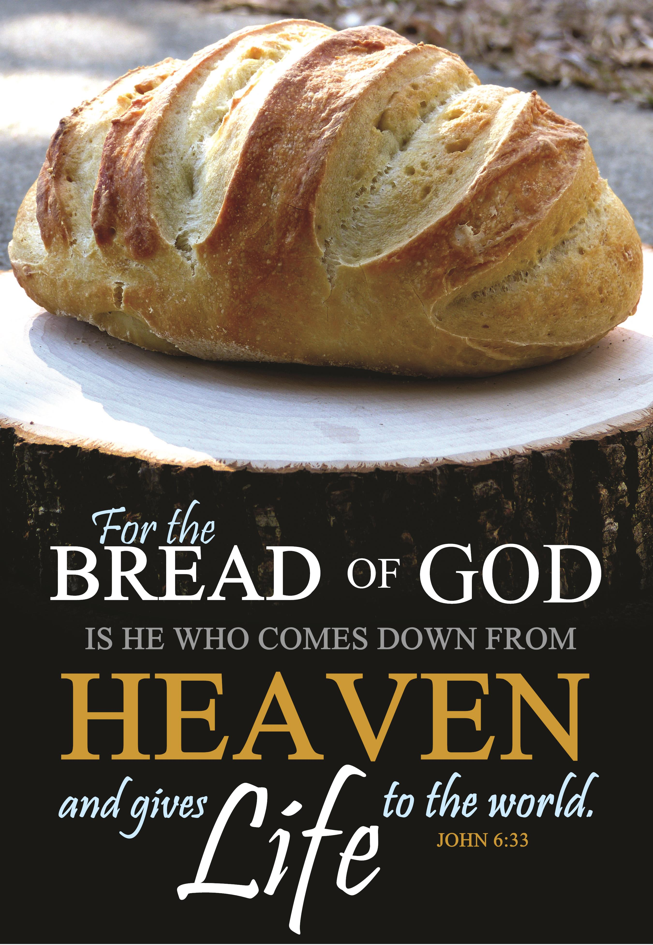
Sunday, May 16, 2021
Worship Today

What do you believe about Jesus? God? How do you know it? From whom did you learn what you believe? What if they’re wrong?

preludes Who Can Satisfy My Soul
Glory to His Name
Brethren, We Have Met to Worship

welcome & announcements

PREPARING FOR WORSHIP
The Promise of God (Ezekiel 36:24-28)
CALL TO WORSHIP Psalm 5:7-8
OPENING PRAYER

SCRIPTURE John 6: 22-40 (NIV)

MORNING PRAYER & LORD’S PRAYER

SPECIAL MUSIC My Father’s World

SCRIPTURE John 6:41-59 (NIV)
Message The Most Important Lesson

DEACON COMMISSIONING

CLOSING PRAYER

special music Untitled Hymn (Come to Jesus)

*BENEDICTION

*Postlude
*Those who are able are invited to stand

Preacher – Pastor Geoff Davis
Worship Leader – Jason Hoffman
Accompanist – Kim Glass
Duets with Cherl Myers
Sound Tech – Mitchell Barnes
Video Tech – Dave Bendit

REPARE YOUR HEARTS FOR WORSHIP NEXT SUNDAY BY READING AHEAD! Next Sunday, Laura Meiser will be preaching on John 6:60-71, Psalm 121. Please read and prayerfully study this passage this week as we prepare to worship together.

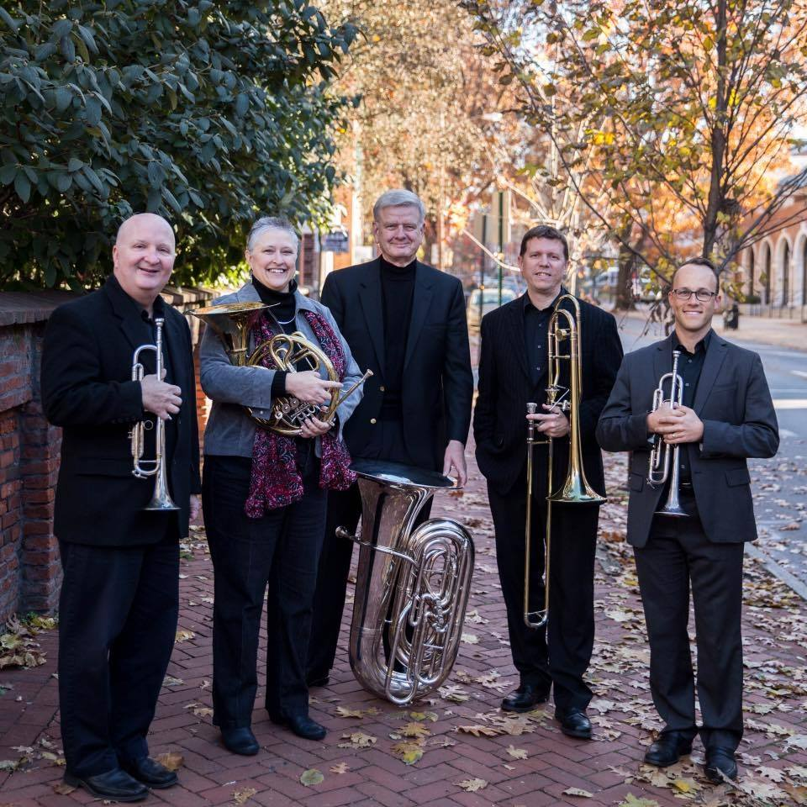
LAWN CONCERT!!
QuintEssentially Brass – Sunday, June 5, 2021 at 6:00pm
Come join us for a great evening of music and fellowship.

Sermon Notes

The Promises of God

“‘For here’s what I’m going to do: I’m going to take you out of these countries, gather you from all over, and bring you back to your own land. I’ll pour pure water over you and scrub you clean. I’ll give you a new heart, put a new spirit in you. I’ll remove the stone heart from your body and replace it with a heart that’s God-willed, not self-willed. I’ll put my Spirit in you and make it possible for you to do what I tell you and live by my commands. You’ll once again live in the land I gave your ancestors. You’ll be my people! I’ll be your God! (Ezekiel 36:24-28, The Message)

- Read the passage to yourself
- What words, phrases or images grab you?
- Read the passage a second time
- What would it mean to your life if God had already fulfilled his promise?
- Listen to the worship leader read the passage a final time
- What does your spirit and your heart say to you?
- How will you worship God this morning?

Announcements

VBS Update: Our VBS may look a little different, but we are ready for the challenge. We are ready to share Jesus with others! We plan to host VBS from Monday, June 14th through Thursday, June 17th. We are asking that parents pre-register their kids on our church website during the month of May. Registration is open at https://vbspro.events/p/events/hcobkids but will close May 31st.
We are also looking for volunteers to help with VBS. Please email Laura Meiser or Emmy Schott if you are interested in helping this year.

Did you know that you can give your tithes and offerings to the church online? Had you forgotten about that option or perhaps how? Well, here you go – consider making your gifts to the church through this convenient and effective method. Hempfield Church of the Brethren activated the "Give Now" function in Breeze. From your Breeze Dashboard on your phone, tablet, or computer, you can click on the "Give Now" button. You will be prompted to provide an amount of your gift or tithe and the fund that you wish to give to. (General, Building, Youth, etc.). You can designate multiple funds and specific amounts to each as well as the frequency (one time, weekly, monthly, etc). Giving can be done through Credit/Debit Cards or by ACH Bank Transfer. While there are service fees associated with this function, the contributor does have the option to pick up the fee as part of the giving. You will be prompted to provide the relevant information and asked to complete your transaction. Upon completion you will receive a confirmation email that your gift has been received and it will be automatically recorded in your Breeze profiles giving tab.

