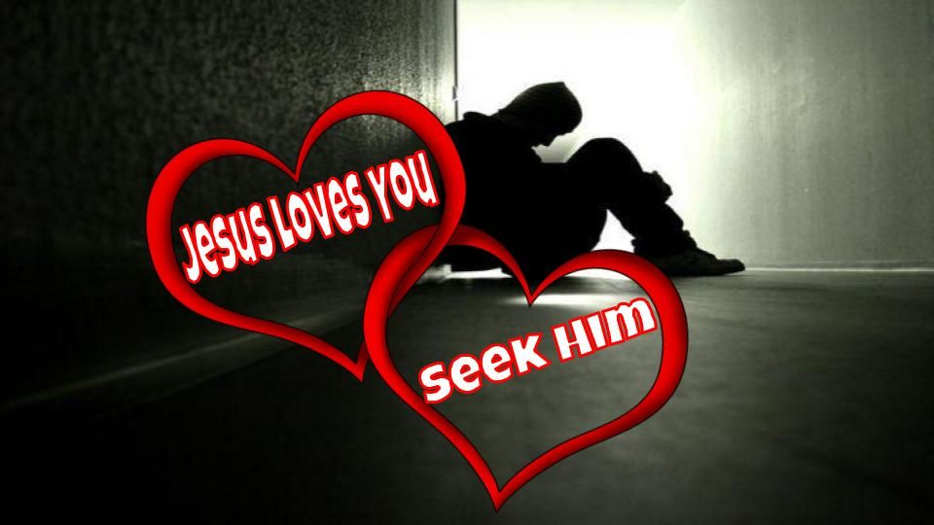
Contact Us
Hempfield Church of the Brethren
Mailing Address: P.O. Box 246, East Petersburg PA 17520
Physical Location: 1186 Stevens Street, Manheim PA 17545
Website: www.hempfieldcob.org

Our staff members are here to help when you need them. Please feel free to contact them if you have a need.

Doug Hinton – Senior Pastor

Cell: 717-951-5290; E-mail: doug@hempfieldcob.org
Scheduled Day Off: Monday

Josh Fulmer – Youth Minister

Cell: 717-723-7732; E-mail: josh@hempfieldcob.org
Scheduled Day Off: Friday

Geoff Davis – Associate Pastor
Home: 717-569-6284; E-mail: gdavis6320@comcast.net

Laura Meiser – Music Director & Children’s Ministry Co-Coordinator

Cell: 717-689-0465; E-mail: laura@hempfieldcob.org

Emmy Schott – Children’s Ministry Co-Coordinator

Cell: 717-333-8216; E-mail: emmy@hempfieldcob.org

Irene Hershey – Administrator

Phone: 717-898-0181; E-mail: office@hempfieldcob.org
Office Hours: Monday - Friday 9:00 A.M. to 3:00 P.M.

Please submit bulletin information to Irene by Wednesday noon.

HCOB Family Facts
Sunday August 19, 2021

General Offering for August 12, 2021 =
General Fund $
Amount needed weekly to meet budget = $10,575
Building Fund for August 12, 2021 = $

Worship Today

preludes

What do you believe about Jesus Christ? Why do you believe it? What are you doing as a result of your beliefs?

welcome & announcements

PREPARING FOR WORSHIP
O God, I Need You

CALL TO WORSHIP Psalm 40:4-8
OPENING PRAYER

SCRIPTURE John 16: 16-24 (NIV)

Praise & Worship

MORNING PRAYER & LORD’S PRAYER

SCRIPTURE John 16:25-333 (NIV)

Message Do You Get It Yet?

HYMN Come, We That Love the Lord
(We’re Marching to Zion)

*BENEDICTION

*Postlude
*Those who are able are invited to stand

Preacher – Pastor Geoff Davis
Worship Leader – Morgan Flick
Accompanist – Kim Glass
Praise Band Leader – Laura Meiser
Sound Tech – Mitchell Barnes & Rich Bushong
Video Tech – Dave Bendit

PREPARE YOUR HEARTS FOR WORSHIP NEXT SUNDAY BY READING AHEAD! Next Sunday, Laura Meiser will be preaching on John 17:1-26. Please read and prayerfully study this passage this week as we prepare to worship together.

HCOB Family Facts
General Offering for September 12, 2021 =
General Fund $
Amount needed weekly to meet budget = $10,575
Building Fund for September 12, 2021 = $

Announcements

Renovations on the first-floor hallway restrooms!! We look forward to the beautiful, new facilities that we will have down there. IN THE MEANTIME, the men’s restrooms on that hallway will be unavailable. We ask the gentlemen of our congregation to use the restrooms on the second floor or in the gymnasium. Thank you for your help and consideration.

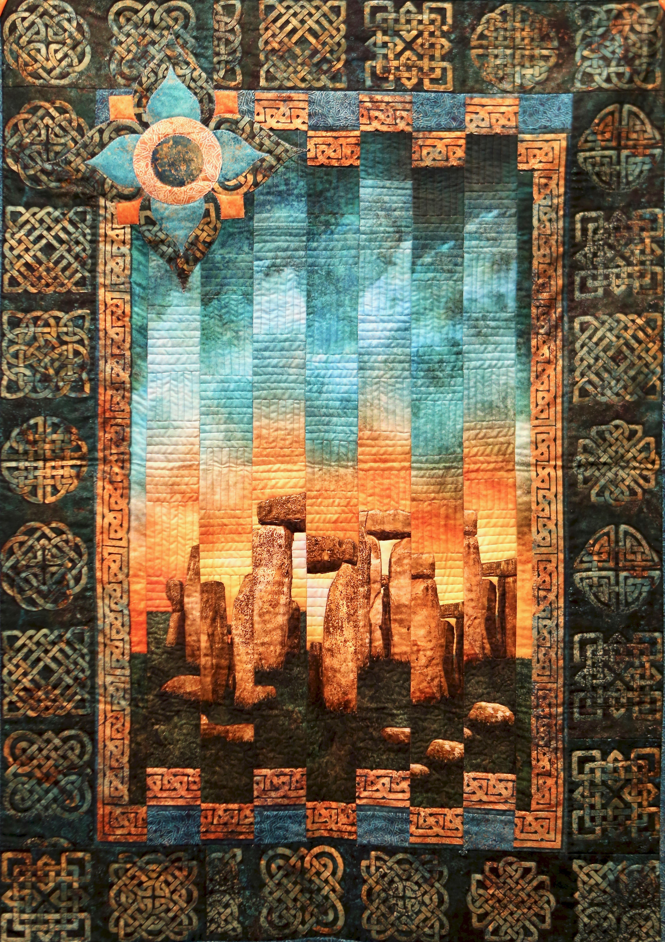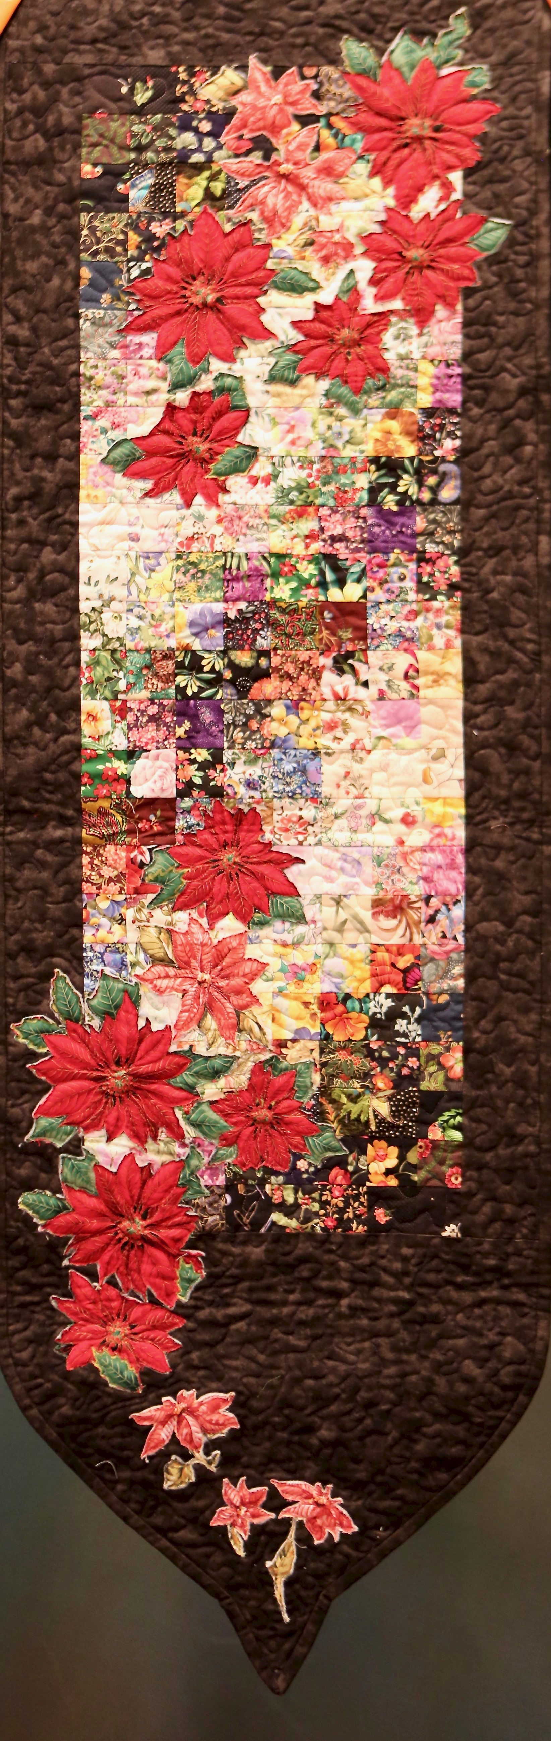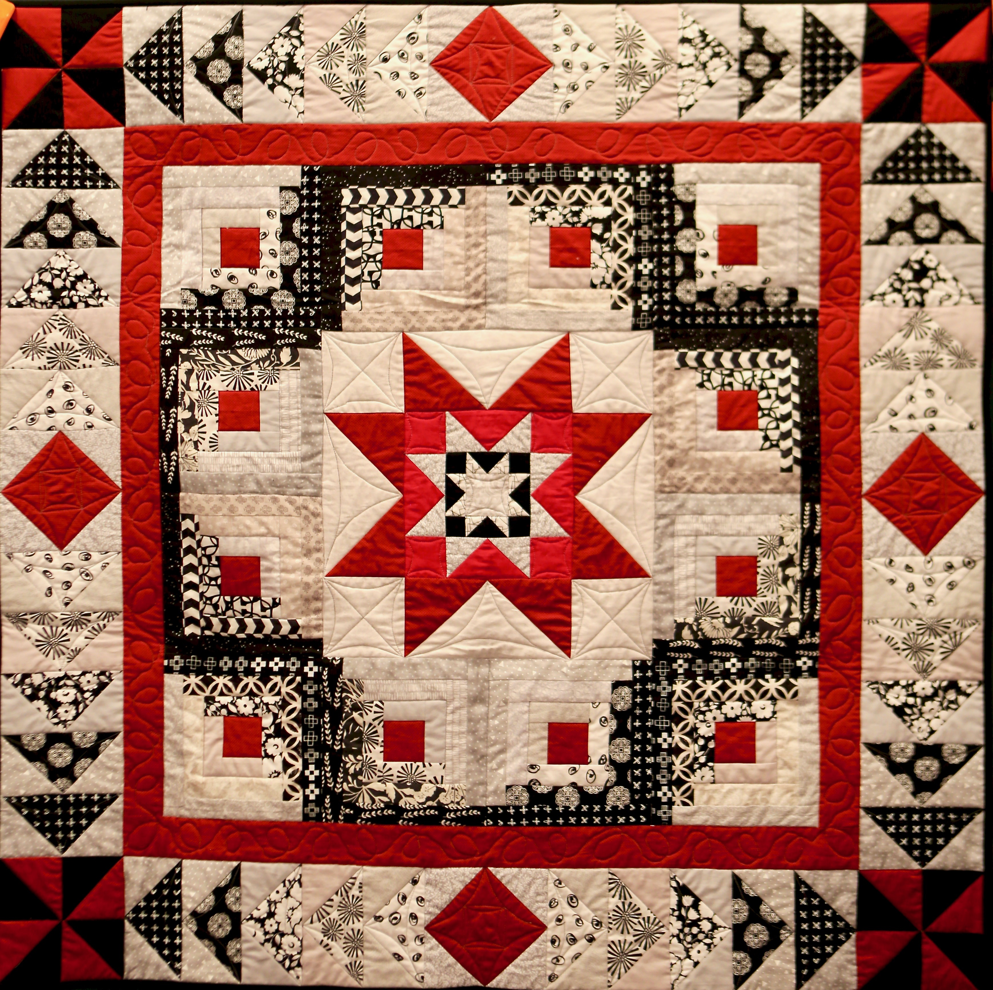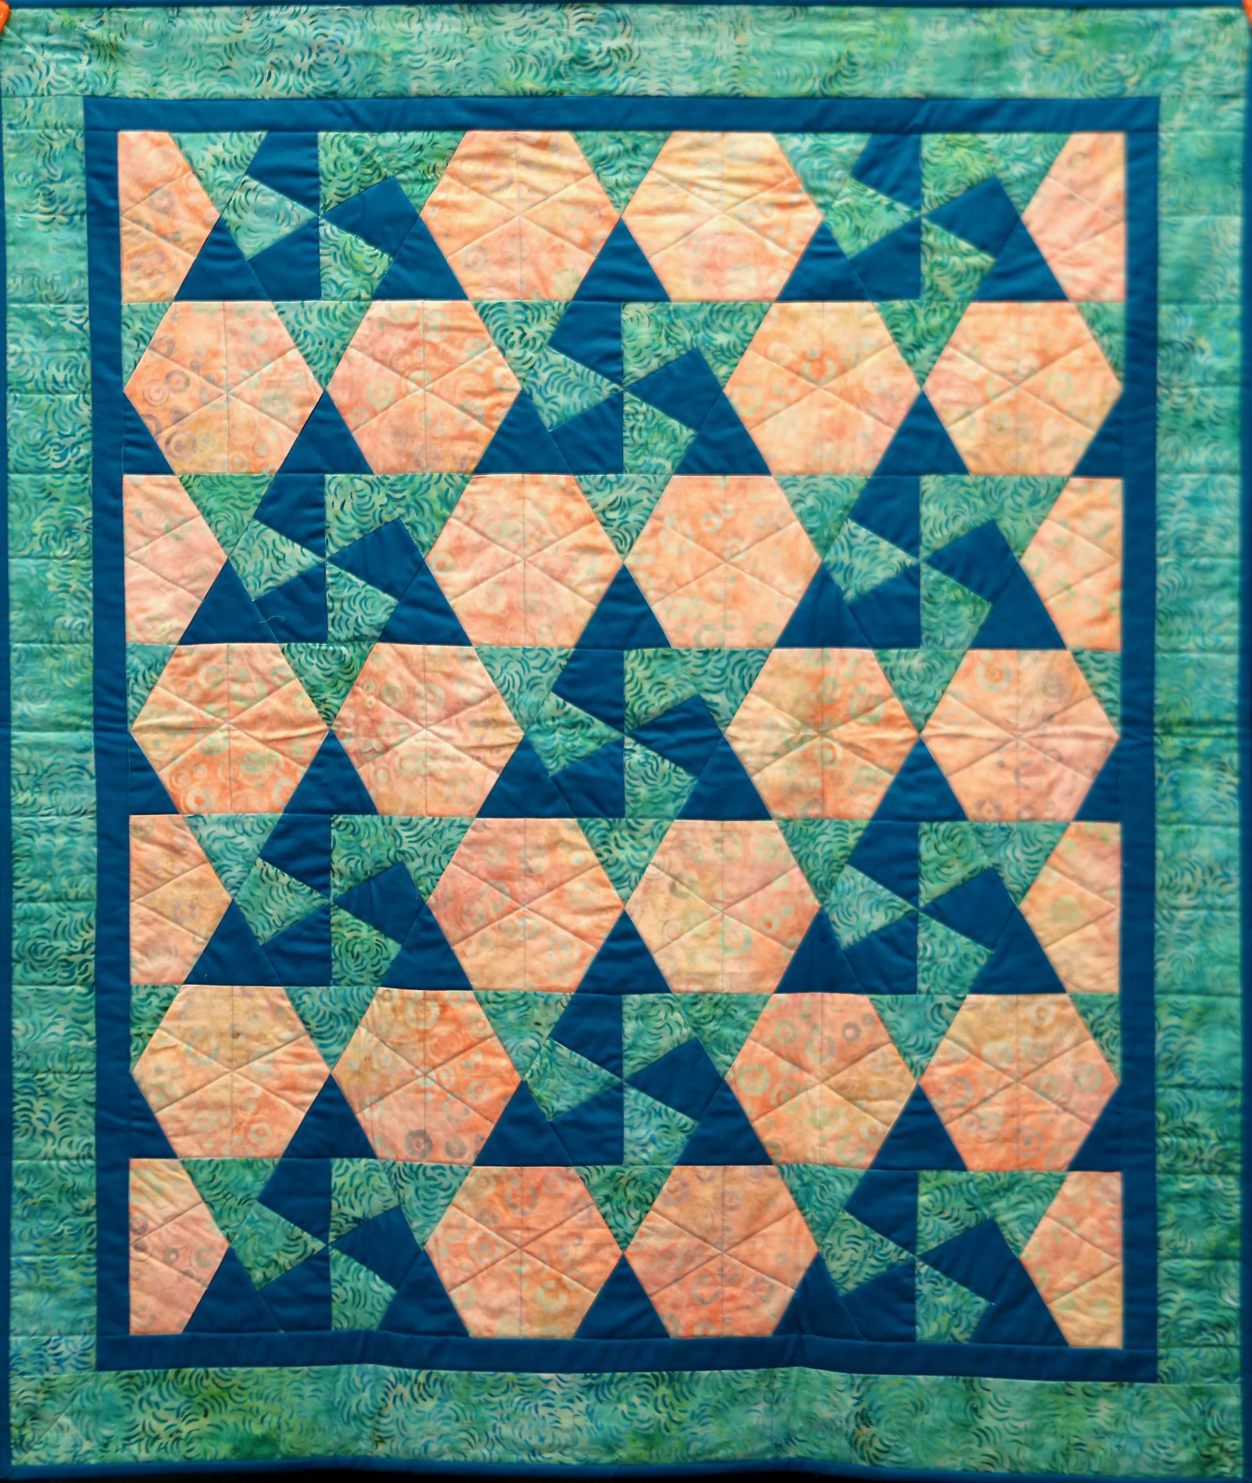

Quilts for BDRA! Today in the narthex are displayed Arlene Slotter’s 22 quilts that will be sold this Saturday, September 25 at 9:30 at the Brethren Disaster Relief Auction at the Lebanon Fairgrounds. The proceeds from the auction support efforts to help after natural disasters such as hurricanes and earthquakes. Arlene humbly says “I want the Lord to get the honor and glory”, and so we ask for your prayers and support for the auction, that God may be glorified!

THERE ARE SO MANY OPPORTUNITIES TO SERVICE THIS COMMUNITY! TAKE A FEW MINUTES TO THINK AND PRAY ABOUT WHERE GOD CAN BEST USE YOU.
November 14, 2021 is the date of the Fall Congregational Gathering at Hempfield Church of the Brethren. It is a time for coming together to shape the work of the church for the coming months. It is also at that time that our Worship Teams reorganize with members who have served their time and make room for those with new and fresh ideas.
BE IN PRAYER ABOUT WHERE GOD CAN USE YOU! Nomination forms will be available for you to consider nominating yourself or someone else that you think my have gifts in particular areas. These forms will be available for the next couple Sundays but MUST be returned to the church NO LATER THAN OCTOBER 3, 2021. For more information, please contact Micki Carper.
September 24 & 25, 2021
The FIRST ANNUAL H.C.O.B.!!
Yes, that is AKA Hempfield Community Outdoor Bash
Did you miss going to Creation 2021? Well, here is your chance to gather with some great community friends new and old and enjoy some great music and fellowship!
Friday evening 6:00 – 9:00 p.m. is geared toward area youth groups!
Saturday Noon to 6:00 p.m. will feature speakers and bands from our local communities.
There will be food trucks, information booths and much more.
You don’t want to miss it!

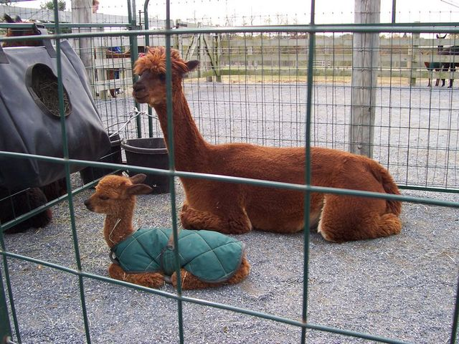
Eastland Alpaca Open House is back again this year, and the youth group is selling food again! They are holding it on November 6th, 7th, 13th, and 14th. below are some ways you can help: Come out and enjoy!
· Bake and donate items for the youth to sell
Money given ahead of time
will purchase supplies.
If baking, please choose from these 4: Cookies, brownies, cupcakes, and rice crispy treats.
Sign up for a slot to join the youth at the stand!
The money from the food stand helps financially support teen events and trips!
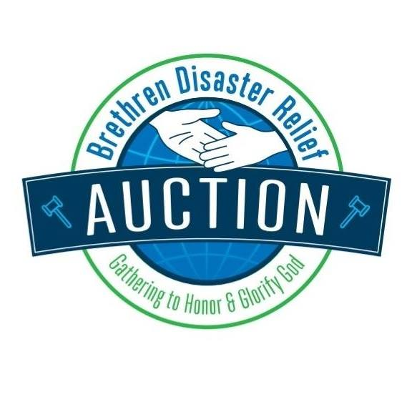
The Brethren Disaster Relief Auction is coming Friday, Sep 24 & Saturday, Sep 25 and your help is needed! There are many ways for you to support the Auction to raise money to help people impacted by hurricanes, earthquakes, fires and floods.
- Our congregation is responsible for serving the Chicken BBQ on Friday evening from 4 to 6 pm. If you can help, please contact Tom Fritz at 717.823.2745 or twfritz@ptd.net.
- The Quilt Committee needs volunteers to help during the quilt auction to get the quilts to those who purchased them. The quilt auction begins at 9:30 am on Saturday and ends around noon. Contact Deb Bendit at 717.808.8453 or quilterdeb60@gmail.com.
- Auction setup is Thursday, Sep 23 starting after 8 am (lunch is provided). Trash collection help is needed Friday & Saturday during the auction and help is especially needed to help clean-up on Saturday after the auction concludes (5 or 6 pm). You can help for as short or long as you want. Contact Chris Keller with any questions or if you are willing to serve in any way! Call or text Chris at 717.269.4052.
For more information about the Auction, go to www.brethrenauction.org. Thank you!

Christmas Shoeboxes for Romania Our church is helping children in Romania again this year by assembling Christmas shoeboxes. My Brother’s Keeper works with children, some in orphanages, throughout the year and provides a gift at Christmas. It is a great opportunity to share the Gospel with the kids, and their parents, if applicable.
WHAT TO PUT IN THE BOX: Toys (small cars, balls, dolls, small stuffed animals, harmonicas, yo-yos, small Etch A Sketch®, Slinky, etc.), school supplies (pens, pencils & sharpener, crayons or markers, coloring books, writing pads or paper, calculators, etc.), other (hard candy, lollipops, mints, gum, ball caps, socks, T-shirts, hair clips, watches, small picture books, stickers, etc.).
DO NOT INCLUDE: Used or damaged items; food or chocolate; liquids or lotions; medications or vitamins.

​HOW TO WRAP THE PACKAGE: Put everything in a shoebox (standard size) or a small plastic container. Wrap it as a gift and place a label on the outside of the package if it is for a boy or girl and the child’s age category. Age categories: 2-4; 5-9; 10-14.
​SHIPPING: Please donate $6 or more with each package for shipping & customs charges. It is important for each of the box to get to Romania. You can write a check to My Brother’s Keeper (note “Christmas shoeboxes” on memo line) and place it in an envelope on top of the gift box. If you are preparing more than one shoe box, please make one combined donation. (Please do not put the money inside the box and then wrap the box.)
Your whole family can participate in this great ministry. Please place boxes under the table in the narthex by Sunday, Oct 10. Thanks for helping to brighten a child’s life! The Outreach Team

