September
2021

Joshua 1:8-9
⁸ This Book of the Law shall not depart from your mouth, but you shall meditate on it day and night, so that you may be careful to do according to all that is written in it. For then you will make your way prosperous, and then you will have good success. ⁹ Have I not commanded you? Be strong and courageous. Do not be frightened, and do not be dismayed, for the Lord your God is with you wherever you go.”
Sunday | Monday | Tuesday | Wednesday | Thursday | Friday | Saturday
 |  |  | 1 | 2 | 3 | 4
5 | 6 | 7 | 8 | 9 | 10 | 11
 | Labor Day
12 | 13 | 14 | 15 | 16 | 17 | 18
Youth Group  Sarah’s Birthday |  |  | Jordan H’s B-day
19 | 20 | 21 | 22 | 23 | 24 | 25
Sunday Funday  Chad’s Birthday |  |  |  |  | Outdoor Bash | Outdoor Bash
26 | 27 | 28 | 29 | 30
Youth Group |  |  |  | Spencer’s Birthday
Blue: Youth Group Green: Holiday/Birthday Purple: Special Event

October
2021
John 10:27-28  ²⁷ My sheep hear my voice, and I know them, and they follow me. ²⁸ I give them eternal life, and they will never perish, and no one will snatch them out of my hand. | 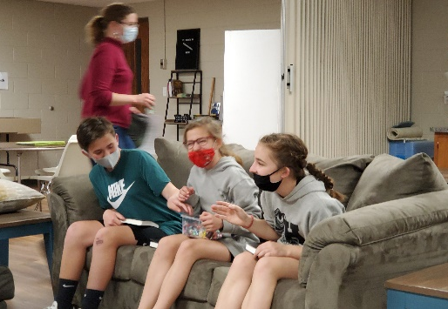
Sunday | Monday | Tuesday | Wednesday | Thursday | Friday | Saturday
 |  |  |  |  | 1 | 2
3 | 4 | 5 | 6 | 7 | 8 | 9
Youth Group
10 | 11 | 12 | 13 | 14 | 15 | 16
Youth Group |  |  |  |  | Fall Retreat | Fall Retreat
17 | 18 | 19 | 20 | 21 | 22 | 23
Fall Retreat
24 | 25 | 26 | 27 | 28 | 29 | 30
Sunday Funday
31
Youth Group
Halloween
Blue: Youth Group Green: Holiday/Birthday Purple: Special Event

November
2021
Ephesians 4:1-2  I therefore, a prisoner for the Lord, urge you to walk in a manner worthy of the calling to which you have been called, ² with all humility and gentleness, with patience, bearing with one another in love, | 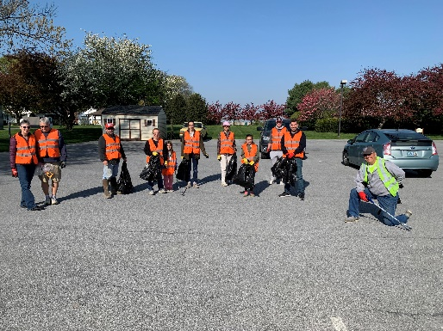
Sunday | Monday | Tuesday | Wednesday | Thursday | Friday | Saturday
 | 1 | 2 | 3 | 4 | 5 | 6
 |  |  |  |  |  | Eastland Alpaca Open House
7 | 8 | 9 | 10 | 11 | 12 | 13
Eastland Alpaca Open House  Youth Group |  |  |  |  |  | Eastland Alpaca Open House
14 | 15 | 16 | 17 | 18 | 19 | 20
Eastland Alpaca Open House
Youth Group
21 | 22 | 23 | 24 | 25 | 26 | 27
Sunday Funday | Maddie’s Birthday |  |  | Thanksgiving
28 | 29 | 30
Youth Group
Blue: Youth Group Green: Holiday/Birthday Purple: Special Event

December
2021

Isaiah 6:8
And I heard the voice of the Lord saying, “Whom shall I send, and who will go for us?” Then I said, “Here I am! Send me.”
Sunday | Monday | Tuesday | Wednesday | Thursday | Friday | Saturday
 |  |  | 1 | 2 | 3 | 4
5 | 6 | 7 | 8 | 9 | 10 | 11
Youth Group
12 | 13 | 14 | 15 | 16 | 17 | 18
Youth Group
19 | 20 | 21 | 22 | 23 | 24 | 25
Sunday Funday  (Christmas Party) |  |  |  |  | Christmas Eve | Christmas
26 | 27 | 28 | 29 | 30 | 31
No Youth Group |  |  |  |  | New Year’s Eve
Blue: Youth Group Green: Holiday/Birthday Purple: Special Event

January
2022

Matthew 28:19-20
¹⁹ Go therefore and make disciples of all nations, baptizing them in^{[a]} the name of the Father and of the Son and of the Holy Spirit, ²⁰ teaching them to observe all that I have commanded you. And behold, I am with you always, to the end of the age.”
Sunday | Monday | Tuesday | Wednesday | Thursday | Friday | Saturday
 |  |  |  |  |  | 1
 |  |  |  |  |  | New Year’s Day
2 | 3 | 4 | 5 | 6 | 7 | 8
Youth Group
Kaiden’s Birthday
9 | 10 | 11 | 12 | 13 | 14 | 15
Youth Group | Gloria’s Birthday
16 | 17 | 18 | 19 | 20 | 21 | 22
Youth Group | MLK Day
23 | 24 | 25 | 26 | 27 | 28 | 29
Sunday Funday
30 | 31
Youth Group
Blue: Youth Group Green: Holiday/Birthday Purple: Special Event

February
2022
1 Samuel 16:7  But the Lord said to Samuel, “Do not look on his appearance or on the height of his stature, because I have rejected him. For the Lord sees not as man sees: man looks on the outward appearance, but the Lord looks on the heart.” | 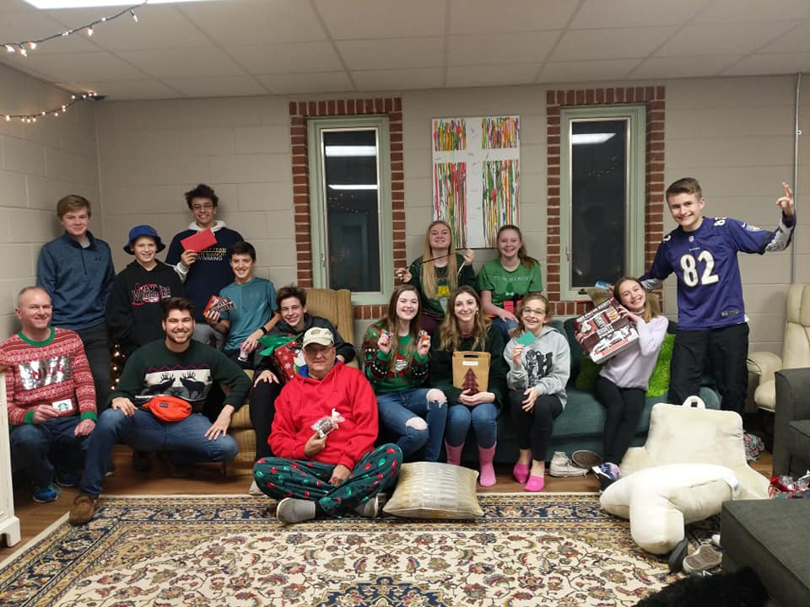
Sunday | Monday | Tuesday | Wednesday | Thursday | Friday | Saturday
 |  | 1 | 2 | 3 | 4 | 5
6 | 7 | 8 | 9 | 10 | 11 | 12
Youth Group
13 | 14 | 15 | 16 | 17 | 18 | 19
Youth Group | Valentine’s Day |  |  |  | Winter Retreat | Winter Retreat
20 | 21 | 22 | 23 | 24 | 25 | 26
Winter Retreat | Winter Retreat  Vanessa’s B-day  Presidents’ Day
27 | 28
Youth Group
Blue: Youth Group Green: Holiday/Birthday Purple: Special Event

March
2022

Jeremiah 31:33
For this is the covenant that I will make with the house of Israel after those days, declares the Lord: I will put my law within them, and I will write it on their hearts. And I will be their God, and they shall be my people.
Sunday | Monday | Tuesday | Wednesday | Thursday | Friday | Saturday
 |  | 1 | 2 | 3 | 4 | 5
6 | 7 | 8 | 9 | 10 | 11 | 12
Youth Group |  |  |  |  |  | Cole’s Birthday
13 | 14 | 15 | 16 | 17 | 18 | 19
Youth Group |  | Grant’s Birthday |  | St. Patrick’s Day
20 | 21 | 22 | 23 | 24 | 25 | 26
Sunday Funday | Micah’s Birthday
27 | 28 | 29 | 30 | 31
Youth Group
Blue: Youth Group Green: Holiday/Birthday Purple: Special Event

April
2022
Luke 9:23  And he said to all, “If anyone would come after me, let him deny himself and take up his cross daily and follow me. | 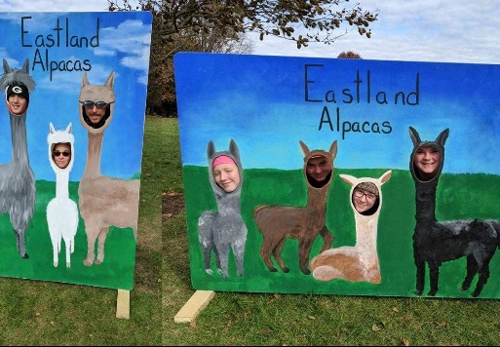
Sunday | Monday | Tuesday | Wednesday | Thursday | Friday | Saturday
 |  |  |  |  | 1 | 2
 |  |  |  |  | Penas’ Birthday
3 | 4 | 5 | 6 | 7 | 8 | 9
Youth Group
10 | 11 | 12 | 13 | 14 | 15 | 16
Palm Sunday  Youth Group |  |  |  | Maundy Thursday | Good Friday
17 | 18 | 19 | 20 | 21 | 22 | 23
No Youth Group
Easter
24 | 25 | 26 | 27 | 28 | 29 | 30
Youth Group |  |  |  |  | Trinity’s Birthday
Blue: Youth Group Green: Holiday/Birthday Purple: Special Event

May
2022
2 Corinthians 5:17  Therefore, if anyone is in Christ, he is a new creation.^{[a]} The old has passed away; behold, the new has come. | 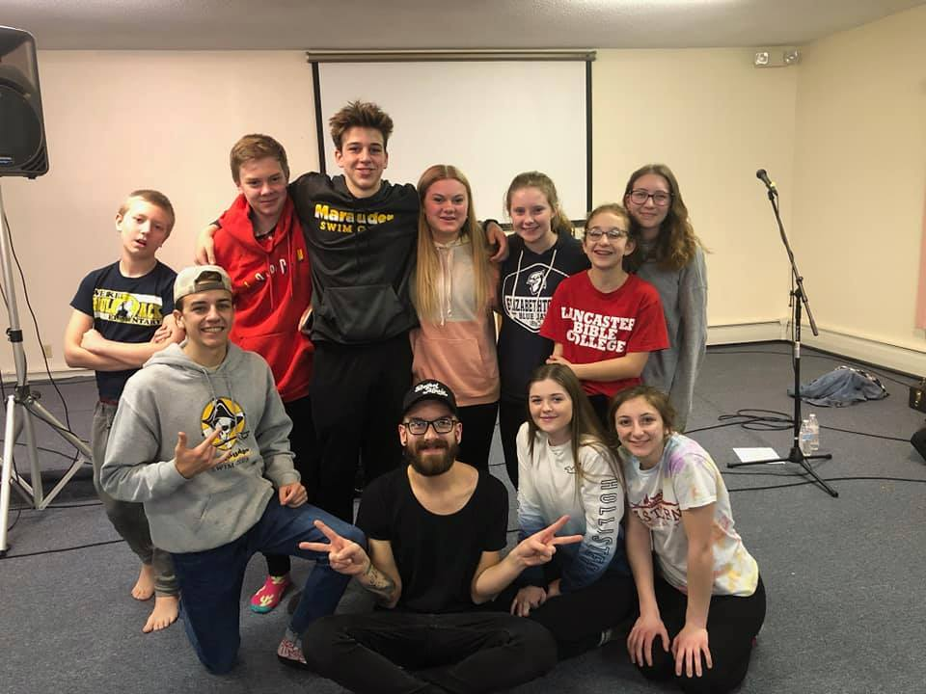
Sunday | Monday | Tuesday | Wednesday | Thursday | Friday | Saturday
1 | 2 | 3 | 4 | 5 | 6 | 7
Youth Group |  |  |  | Cinco de Mayo
8 | 9 | 10 | 11 | 12 | 13 | 14
No Youth Group
Mother’s Day
15 | 16 | 17 | 18 | 19 | 20 | 21
Youth Group
22 | 23 | 24 | 25 | 26 | 27 | 28
Last Youth Group
Lily’s Birthday
29 | 30 | 31
No Youth Group | Memorial Day
Blue: Youth Group Green: Holiday/Birthday Purple: Special Event

June
2022
1 Timothy 4:12  Let no one despise you for your youth, but set the believers an example in speech, in conduct, in love, in faith, in purity. | 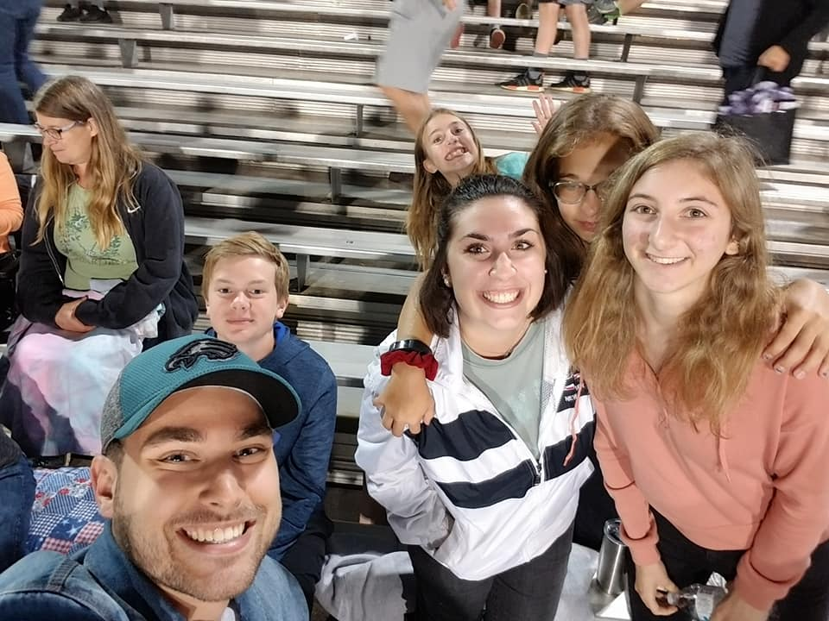
Sunday | Monday | Tuesday | Wednesday | Thursday | Friday | Saturday
 |  |  | 1 | 2 | 3 | 4
5 | 6 | 7 | 8 | 9 | 10 | 11
12 | 13 | 14 | 15 | 16 | 17 | 18
Sunday Funday
19 | 20 | 21 | 22 | 23 | 24 | 25
Father’s Day
26 | 27 | 28 | 29 | 30
Sunday Funday |  | Creation | Creation | Creation
Blue: Youth Group Green: Holiday/Birthday Purple: Special Event

July
2022
Romans 3:22-24  ²² the righteousness of God through faith in Jesus Christ for all who believe. For there is no distinction: ²³ for all have sinned and fall short of the glory of God, ²⁴ and are justified by his grace as a gift, through the redemption that is in Christ Jesus | 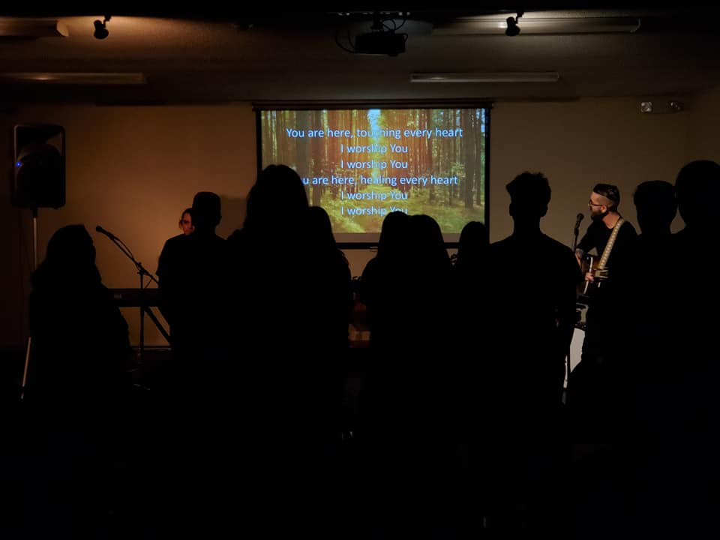
Sunday | Monday | Tuesday | Wednesday | Thursday | Friday | Saturday
 |  |  |  |  | 1 | 2
 |  |  |  |  | Creation | Creation
3 | 4 | 5 | 6 | 7 | 8 | 9
Creation | Independence Day | Rose & Lily’s Birthday
10 | 11 | 12 | 13 | 14 | 15 | 16
Sunday Funday
17 | 18 | 19 | 20 | 21 | 22 | 23
24 | 25 | 26 | 27 | 28 | 29 | 30
Sunday Funday |  |  |  |  |  | Landen’s Birthday
31
Blue: Youth Group Green: Holiday/Birthday Purple: Special Event

August
2022

Mark 16:16
Whoever believes and is baptized will be saved, but whoever does not believe will be condemned.
Sunday | Monday | Tuesday | Wednesday | Thursday | Friday | Saturday
 | 1 | 2 | 3 | 4 | 5 | 6
7 | 8 | 9 | 10 | 11 | 12 | 13
Sunday Funday |  |  |  |  |  | Josh’s Birthday
14 | 15 | 16 | 17 | 18 | 19 | 20
21 | 22 | 23 | 24 | 25 | 26 | 27
Sunday Funday
28 | 29 | 30 | 31
Blue: Youth Group Green: Holiday/Birthday Purple: Special Event

