Contact Us

*Hempfield Church of the Brethren*

*Mailing Address*: P.O. Box 246, East Petersburg PA 17520

*Physical Location:* 1186 Stevens Street, Manheim PA 17545

*Website:* www.hempfieldcob.org

*Our staff members are here to help when you need them. Please feel free to contact them if you have a need.*

Doug Hinton *– Senior Pastor*

Cell: 717-951-5290; E-mail: [doug@hempfieldcob.org](mailto:doug@hempfieldcob.org)

*Scheduled Day Off: Monday*

Josh Fulmer – *Youth Minister*

Cell: 717-723-7732; E-mail: josh@hempfieldcob.org

*Scheduled Day Off: Friday*

Geoff Davis *– Associate Pastor*

Home: 717-569-6284; E-mail: [gdavis6320@comcast.net](mailto:gdavis6320@comcast.net)

Laura Meiser *– Music Director & Children’s Ministry Co-Coordinator*

Cell: 717-689-0465; E-mail: [laura@hempfieldcob.org](mailto:laura@hempfieldcob.org)

Emmy Schott *– Children’s Ministry Co-Coordinator*

Cell: 717-333-8216; E-mail: [emmy](https://hempfieldcob.breezechms.com/people/view/1104762)@hempfieldcob.org

Irene Hershey– *Administrator*

Phone**:** 717**-**898-0181; E-mail: [office@hempfieldcob.org](mailto:office@hempfieldcob.org)

Office Hours: Monday - Friday 9:00 A.M. to 3:00 P.M.

*Please submit bulletin information to Irene by Wednesday noon.*

HCOB Family Facts

**General Offering for October 10, 2021 =**

General Fund $ 10,405.00

*Amount needed weekly to meet budget = $10,575*

**Building Fund for October 19, 2021 = $** 680.00

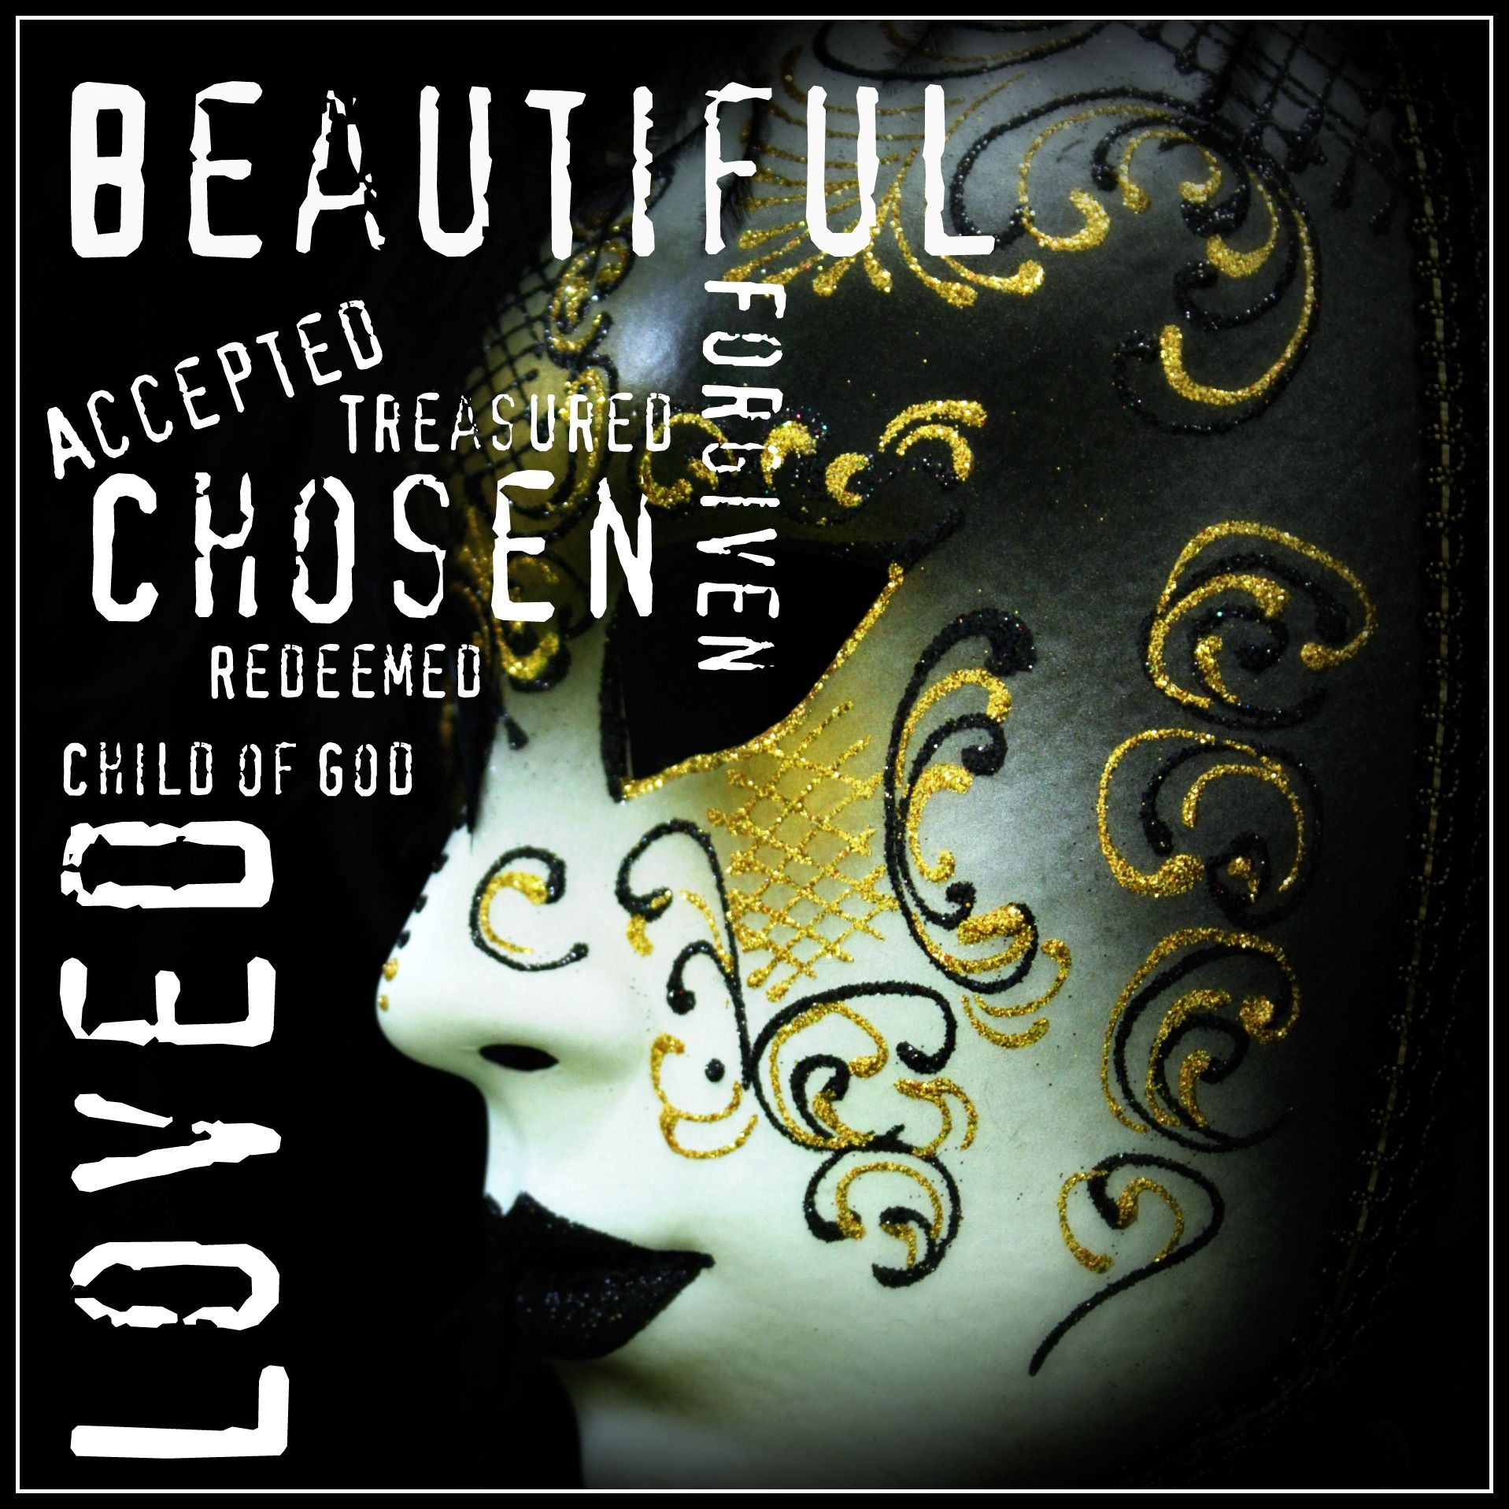

Sunday October 17, 2021

Worship Today

*When you consider how you currently spend your time, what matters most to you in your day-to-day living? Where does following Jesus Christ fall on your list? What’s one small step you might try to make Jesus the top of your list?*

preludes

welcome & announcements

OUTREACH IN ACTION:  Stephanie Smith,

Director of Operations, Bible 2 School

CALL TO WORSHIP Psalm 66:1-4

PREPARING FOR WORSHIP *Finding God* (Thomas Merton)

SCRIPTURE John 18: 1-14

PRAISE & WORSHIP

SCRIPTURE John 18:15-27

MORNING PRAYER & LORD’S PRAYER

SPECIAL MUSIC Sanctuary Choir

SCRIPTURE John 18:28-40

Message ***What Matters Most?***

HYMN Jesus Shall Reign #319

*BENEDICTION Hymnal #680

*Postlude

\**Those who are able are invited to stand*

Preacher – Pastor Geoff Davis

Worship Leader – Jen Hinton

Accompanist – Kim Glass

Praise Band Leader – Laura Meiser

Sound Tech – Mitchell Barnes & Rich Bushong

Video Tech – Dave Bendit

**PREPARE YOUR HEARTS FOR WORSHIP NEXT SUNDAY BY READING AHEAD!** Next Sunday, **Doug Hinton** will be preaching on **John 19:17-42, Romans 8:31-39, Hebrews 12:1-3**.Please read and prayerfully study this passage this week as we prepare to worship together.



**IT IS NEW DIRECTORY TIME – HAVE YOU?**

* **Dropped a phone line**
* **Changed or added a phone number**
* **Changed addresses**
* **Added or changed an email address**
* **Had a family member move to a different address**
* **Made any other changes to your information**

If you answered “yes” to any of the above, please send that information to Irene so she can make appropriate updates. Thanks!!

As we look to have the restrooms completed by Christmas, the Building Fund could still use your help to complete the project. Please consider a donation to the Building Fund.

A HUGE **THANK YOU** to everyone who made **Christmas Shoeboxes for Romanian children**.  Our church lovingly packed 27 boxes which were delivered to My Brother's Keeper last week.  These Christmas gifts will be given to children in Romanian orphanages and villages.  Please pray for the children who will receive them and for their families.  The Outreach Team

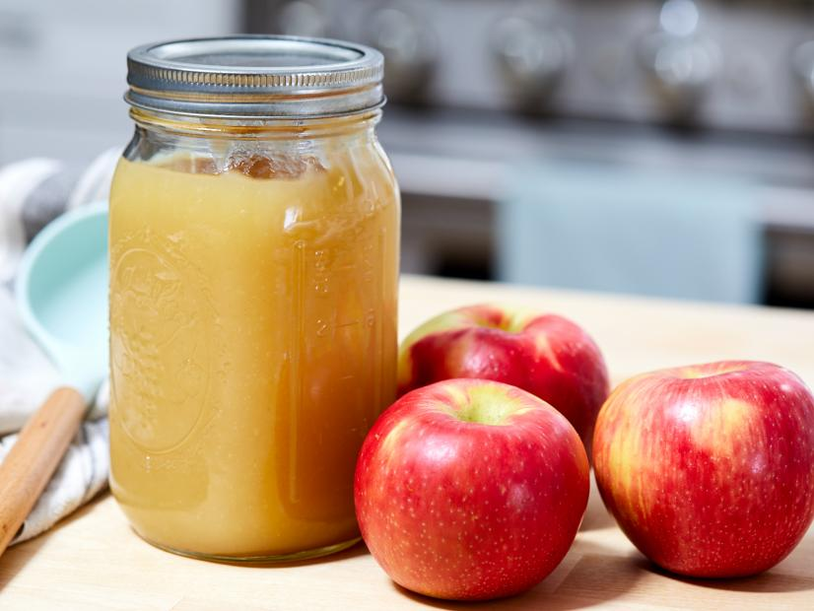Fellowship and Hospitality team will be making applesauce starting at 4:30 p.m on Monday, October 25th. We are freezing and canning the applesauce. If you have any Quart canning jars you are willing to donate, please put them in a box outside the kitchen.

**We could use your help!!** Please let Penny Kettering or Mary Lou Ruth know that we can expect you. This applesauce is used by the CCC, Deacons, and pastors hand out during their visits.

A **HUGE** thank you to all who turned out and helped or participated in last Sunday’s FALL FEST. It was a great success and a wonderful afternoon of fellowship and fun.

There will be an **NYC (Youth National Conference)** information and UPDATE meeting after the church service on **Sunday October 24th**. We will meet in the youth room on the second floor. Ed Haldeman will share information about the 2022 NYC for students and parents of those planning on attending and those still deciding. Registration opens Dec 1st so those “on the fence“ will need to decide by December 1st. Hope to see you then!

(Note : November DC Service project trip for 2021 has been postponed till 2022)

Announcements

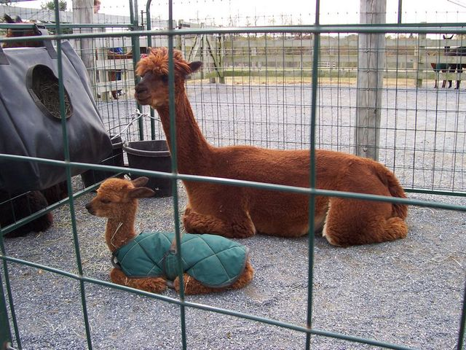**Eastland Alpaca Open House** is back again this year, and the youth group is selling food again! They are holding it on November 6th, 7th, 13th, and 14th. below are some ways you can help: Come out and enjoy!

·        Bake and donate items for the youth to sell

Money given ahead of time

will purchase supplies.

If baking, please choose from these 4:  Cookies, brownies, whoopie pies, and rice crispy treats. All baked items MUST be individually wrapped.

Sign up for a slot to join the youth at the stand!

The money from the food stand helps financially support teen events and trips!



The Outreach Team recently gave an offering of $2,000 to Church World Service in Lancaster to provide financial support to help resettle Afghanistan refugees coming to our community. (The money came from the Outreach Opportunities budget line 831.) From a denomination perspective, a new joint Church of the Brethren and Church World Service effort supporting the resettlement of Afghan evacuees in the US was approved by the Mission and Ministry Board including a grant of $52,000 from the Emergency Disaster Fund. We are blessed to join together in prayer, love, and action to protect vulnerable Afghans fleeing violence and persecution, asJ*e*sus said: “I was a stranger and you welcomed me.” (Matthew 25:35)

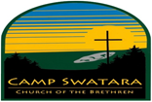

**Dear Camp Representatives.**

2021 Contributor’s Dinner scheduled for Friday, November 5th, 2021. We will provide two seating options this year, the first beginning at 12:00PM and the second beginning at 5:30PM. Tables of 6 guests will cost $750.00 per table and individual tickets are $65.00 per person. If you are interested in attending, please see the letter and registration form attached to the bulletin email this week.

**INTERESTED IN HELPING WITH THE DINNER?**

Camp Swatara will be hosting the 2021 Contributor's Dinner on Friday, November 5, 2021. We will need dining room servers for this event. Could you please check with adults in your congregation that could serve for a few hours? Also, we had youth groups from different churches that have used this as a service project so please talk to your youth advisors.

  We will be having two meals.  The first seating guest will arrive at 12 noon for hors'deuvres, and have dinner at 12:30 pm. We will need 6 to 12 servers for the noon meal. Servers will need to be at camp from 11am to 3pm.

The second seating will arrive at 5:30 pm for hors'deuvres , and have dinner at 6pm. We will need serves for the evening meal from 4pm to 7pm.

All servers should dress in black bottoms and white tops.

Please contact me at foodservice@campswatara.org or call me at 717 933-8510 ext 106 if any of your church members could help.

Thanks

Chef Bob Biddle

Wilda Drake would like to thank everyone for their calls, cards and prayers during her recent hospitalization. She is home now and while she would enjoy phone calls, she is not ready for visitors.

Sermon Notes