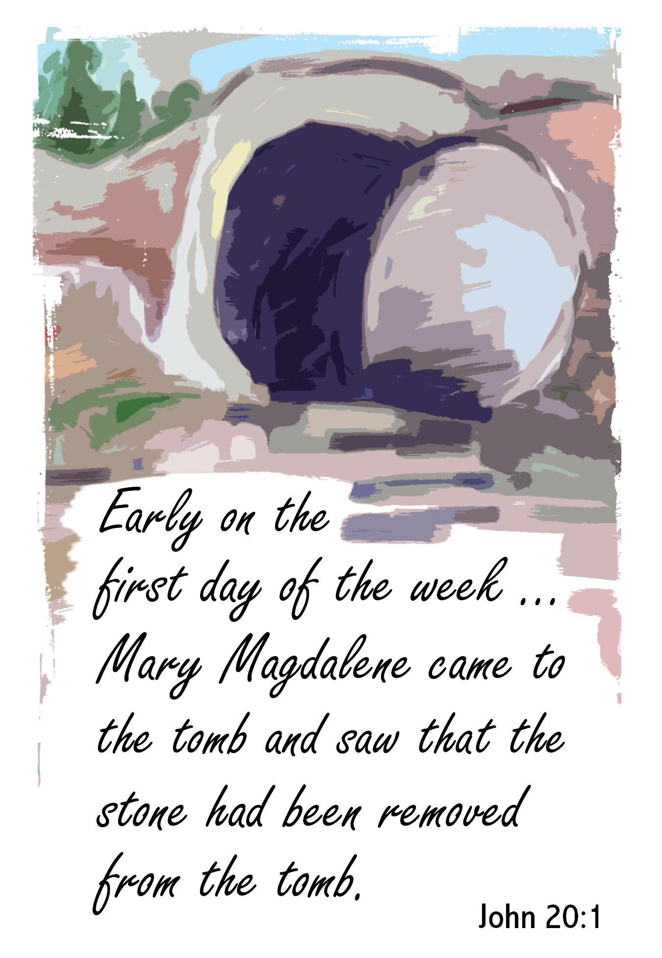
Contact Us
Sunday, November 7, 2021
Hempfield Church of the Brethren
Mailing Address: P.O. Box 246, East Petersburg PA 17520
Physical Location: 1186 Stevens Street, Manheim PA 17545
Website: www.hempfieldcob.org

Our staff members are here to help when you need them. Please feel free to contact them if you have a need.

Doug Hinton – Senior Pastor

Cell: 717-951-5290; E-mail: doug@hempfieldcob.org
Scheduled Day Off: Monday

Josh Fulmer – Youth Minister

Cell: 717-723-7732; E-mail: josh@hempfieldcob.org
Scheduled Day Off: Friday

Geoff Davis – Associate Pastor
Home: 717-569-6284; E-mail: gdavis6320@comcast.net

Laura Meiser – Music Director & Children’s Ministry Co-Coordinator

Cell: 717-689-0465; E-mail: laura@hempfieldcob.org

Emmy Schott – Children’s Ministry Co-Coordinator

Cell: 717-333-8216; E-mail: emmy@hempfieldcob.org

Irene Hershey – Administrator

Phone: 717-898-0181; E-mail: office@hempfieldcob.org
Office Hours: Monday - Friday 9:00 A.M. to 3:00 P.M.
Please submit bulletin information to Irene by Wednesday noon.

HCOB Family Facts
Sunday August 19, 2021
General Offering for October 31, 2021 =
General Fund $ 10,295.00
Amount needed weekly to meet budget = $10,575
Building Fund for October 31, 2021 = $ 3240.00

This Week @ H.C.O.B.

Today: Wednesday:
Alpaca Sale 7:00pm Choir Practice
Monday: 7:00pm Property Team
Doug’s Day Off Thursday:
Tuesday:
7:00pm Worship Team Friday:
Josh’s Day Off
Worship Today

preludes
welcome & announcements

OUTREACH IN ACTION: Alpha and Omega Church of the Brethren – Joel Pena

CALL TO WORSHIP Psalm 16

OPENING PRAYER

SPECIAL MUSIC Praise Band

SCRIPTURE Genesis 3:1-13

MORNING PRAYER & LORD’S PRAYER

SPECIAL MUSIC Jesus, Your Name
Sanctuary Choir

SCRIPTURE John 20:1-18

Message Peter, John, & Mary
HYMN He Lives Insert

*BENEDICTION

*Postlude

*Those who are able are invited to stand

Preacher – Pastor Doug Hinton
Worship Leader – Del Kautz
Accompanist – Jen Hinton
Praise Band Leader – Laura Meiser
Sound Tech – Rich Bushong & Blaine Garber
Video Tech – Dave Bendit

PREPARE YOUR HEARTS FOR WORSHIP NEXT SUNDAY BY READING AHEAD! Next Sunday, Laura Meiser will be preaching on John 20: 19-31. Please read and prayerfully study this passage this week as we prepare to worship together.

IT IS NEW DIRECTORY TIME – HAVE YOU?
- Dropped a phone line
- Changed or added a phone number
- Changed addresses
- Added or changed an email address
- Had a family member move to a different address
- Made any other changes to your information
If you answered “yes” to any of the above, please send that information to Irene so she can make appropriate updates. Thanks!!

As we look to have the restrooms completed by Christmas, the Building Fund could still use your help to complete the project. Please consider a donation to the Building Fund.

Greetings. Requested items for November:
Cereal, Small and large oatmeal, Instant oatmeal, Canned carrots, Canned mixed vegetables, Canned corn, Canned peas, Canned green beans,
Large jelly (prefer no glass jars), Small jelly (prefer no glass jars), Canned chicken noodle soup, Canned peaches, Canned mixed fruit,
Canned mandarin oranges.
Money donations can be sent as follows:
Hempfield Area Food Pantry - 85 East Brandt Blvd., Landisville, PA 17538
Manheim Central Food Pantry - c/o Salem UMC, 140 North Penn Street
Manheim, PA 17545
Or mail to Pete Cope and it will be delivered to the Pantry.
Please mark Hempfield COB Donation in the memo line for reporting purposes.
Thank you for your continuing faithful support of this ministry.

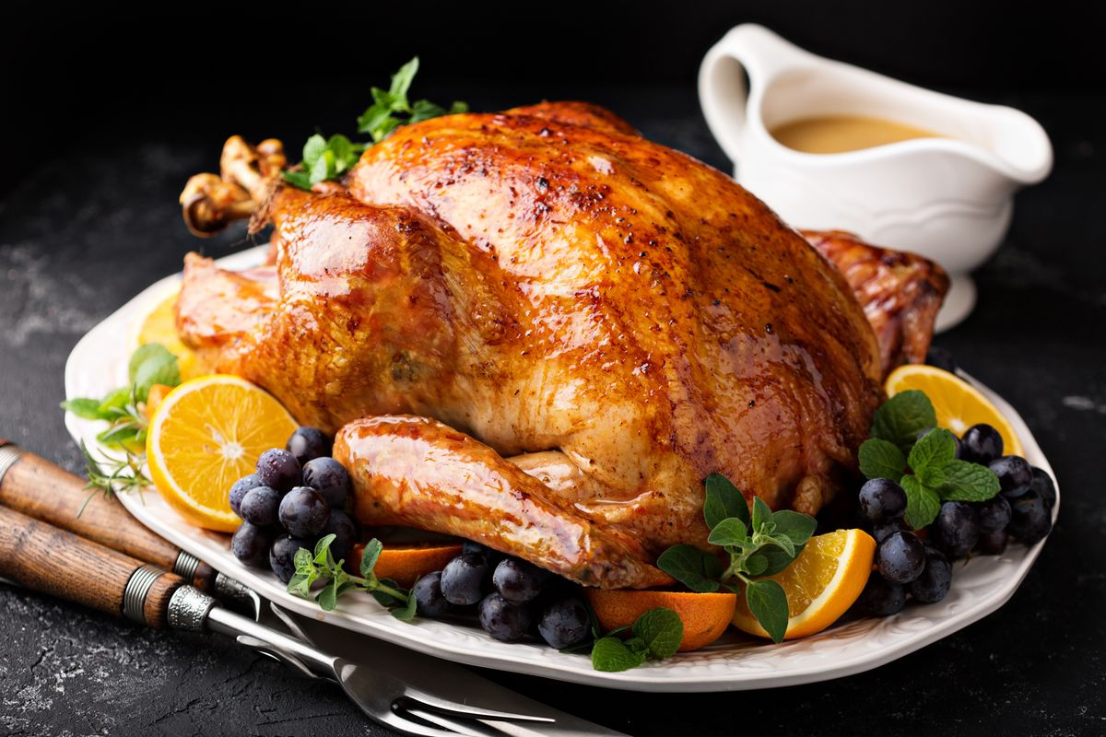
Turkey Drive 11/21 – The Force for Food Committee is coordinating the annual turkey collection for Water Street Ministries. Water Street needs 4,500 turkeys to provide over 37,000 holiday meals. Monetary donations would also be appreciated and can be placed in the collection box in the narthex. Please make checks payable to Hempfield Church of the Brethren (notation-Turkey Drive). November 21st we will be collecting frozen or fresh turkeys outside the gym. Water Street Ministries shelters 170 people per night and serves 146,000 meals annually. Thank you for your annual support in providing a holiday meal to those in need during these challenging times.

Announcements

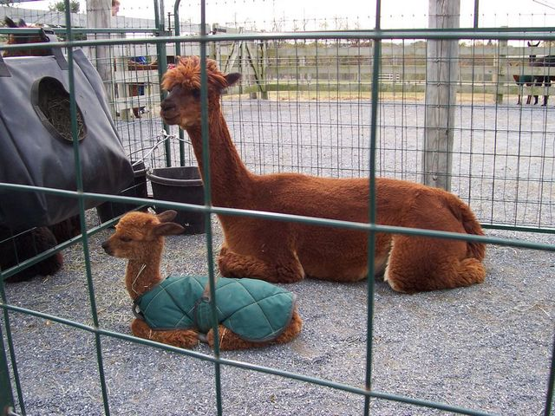
Eastland Alpaca Open House is back again this year, and the youth group is selling food! They are holding it on November 6th, 7th, 13th, and 14th. below are some ways you can help: Come out and enjoy!
The money from the food stand helps financially support teen events and trips!

Friday, November 19th at 5:30 p.m. : Date Night for Parents - Drop your kids off at the church while you take some time for yourselves. We will provide dinner and activities for the children that evening.
If you’d like to attend, please register at https://forms.gle/5Yf1A3623sVqMLMv6
Registration closes on November 7 so don’t delay!
Questions? Please contact Laura Meiser (717.689.0465) or Emmy Schott (717.333.8216). Hope to see you there!

CONGREGATIONAL GATHERING
Sunday, November 14, 2021 - Following the Sunday morning worship service.

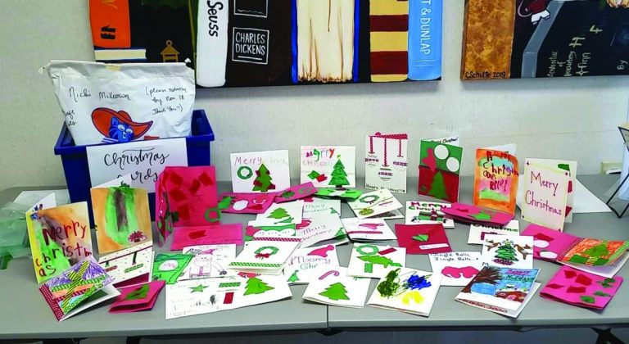
CHRISTMAS CARDS FOR OUR SENIORS.
If you would like to participate in providing a Christmas card for our shut-ins and those in Senior Homes, please be aware of the following:
- Obtain a list of those individuals from the table in the Narthex.
- Alphabetize (by last name) and band your cards together.
- Place your cards in the marked box under the Narthex table by December 5th. Please include cards for persons on the list only.
- This mailing is postage free and requires only the name of the recipient on the envelop and your signature inside.
- Cards will be delivered with baskets the weekend of December 11th.

A Celebration of Life service was held here yesterday for Gloria Brumbaugh, beloved wife of Galen Brumbaugh. We pray for peace for her family through this time.

Hempfield Church of the Brethren has recently 2 new lives into our midst. We celebrate these lives and the families that God has placed them in. Please welcome…..
Hadrian Kleinfelter, born September 9, 2021
Elizabeth Grace Crawford born October 14, 2021

Gingerbread House Night!! December 5th from 3:30-5:30pm. Come make a festive, edible home! This is open to everyone and refreshments will be provided. Once completed, houses can be placed in the Narthex for a congregational vote!
Following this, we will also spread Christmas cheer caroling around East Petersburg starting a 5. If you are interested in either event, sign-up in the narthex from November 7th-21st. Please contact Josh or Emmy if you have any questions!

Sermon Notes

