Hempfield Church of the Brethren
Parent/Guardian Permission for Special Event/Activity

Dear Parent/Guardian:

Your son/daughter is encouraged to participate in Hempfield Youth Ministry’s Winter Retreat. This activity will take place under the guidance and supervision of at least two authorized/approved personnel from Hempfield Church of the Brethren. If you child would like to invite a friend, please contact Pastor Josh - the more the merrier!

Name of event: Winter Retreat
Destination: Montrose Bible Conference, Montrose, PA
Departure from Hempfield CoB February 18, 2022 at 5:30 pm
Additional: We will meet at the church Friday at 4:30pm, so that we can leave by 5:30pm.
Return to Hempfield CoB: February 21, 2022 at 3:00 pm
Additional: We will need time to unload trailers and van. Everyone is expected to stay and help .
Method of Transportation: 15-passenger van(s)

Designated approved adult supervisors:
1. Pastor Josh Fulmer cell # 717.723.7732
2. Morgan Flick cell # 717.413.7712

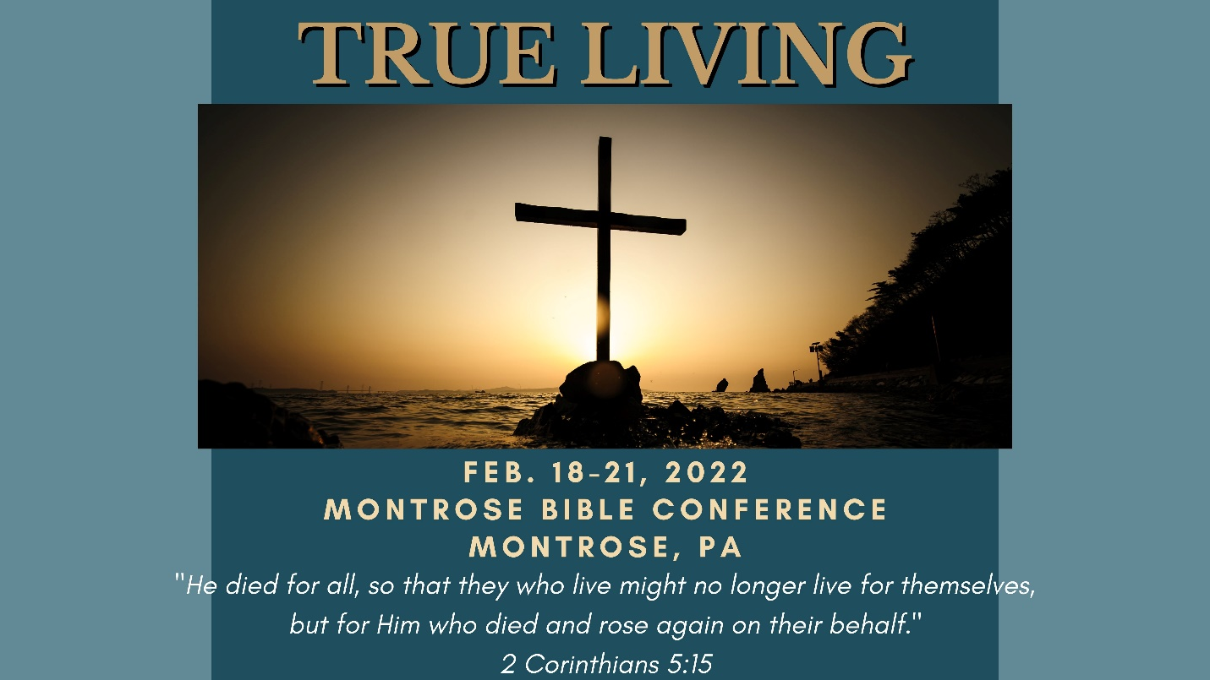
Participant’s Cost: $10 deposit (due 1/23 w/ form)
Additional information/cost:
Please bring money for the trips on Friday and Monday.
Our theme for this weekend will be “True Living”. See the event flyer for elaboration.

What to bring:
Warm clothes (including snow clothes), athletic wear, Toiletries (towel, soap, shampoo, toothbrush, tooth paste, washcloth, etc.), Bible, pen, & journal (everyone should have one 😉), Bedding: sheets or sleeping bags, pillows, blanket, and money for stops on our travels

What NOT to bring:
Weapons of any kind, including pocket knives, Laptops, tablets, gaming consoles/devices, Fireworks or explosives, Drug paraphernalia, Inappropriate attire

* Cell Phones are permitted but are only allowed at appropriate times*

If you would like your child/children to participate in this event, please sign and return the permission form below by 1/23/2022. As the parent or legal guardian, you remain responsible for any legal responsibility which may result from actions taken by the named child/children.

IF YOUR CHILD DOES NOT HAVE REGISTRATION/INFORMATION FORM ON FILE, ONE MUST BE COMPLETED AND GIVEN TO PASTOR JOSH 24 HOURS BEFORE DEPARTURE!

TEAR HERE. KEEP ABOVE FOR YOUR INFORMATION.
_ _ _ _ _ _ _ _ _ _ _ _ _ _ _ _ _ _ _ _ _ _ _ _ _ _ _ _ _ _ _ _ _ _ _ _ _ _ _ _ _ _ _ _ __ _ _ _ _ _ _

Permission Form for Short Term Field Trip/ Retreat Participation

** Return this lower Form by January 23, 2022**

I hereby consent to participation by my child/children:
(name/names) _________________________________________________________________
in HYM Winter Retreat on February 18-21, 2022. I understand that this event will take place away from the church building and that my child/children will be under the supervision of the two authorized/approved adults on the above stated date/dates. I further consent to the stated conditions on participation in this event, including the method of transportation.

_________________________ _______________________________ ___________
Print parent/guardian name parent/guardian signature date

