Contact Us
Sunday, January 2, 2022
Hempfield Church of the Brethren
Mailing Address: P.O. Box 246, East Petersburg PA 17520
Physical Location: 1186 Stevens Street, Manheim PA 17545
Website: www.hempfieldcob.org

Our staff members are here to help when you need them. Please feel free to contact them if you have a need.

Doug Hinton – Senior Pastor

Cell: 717-951-5290; E-mail: doug@hempfieldcob.org
Scheduled Day Off: Monday

Josh Fulmer – Youth Minister

Cell: 717-723-7732; E-mail: josh@hempfieldcob.org
Scheduled Day Off: Friday

Geoff Davis – Associate Pastor
Home: 717-569-6284; E-mail: gdavis6320@comcast.net

Laura Meiser – Music Director & Children’s Ministry Co-Coordinator

Cell: 717-689-0465; E-mail: laura@hempfieldcob.org

Emmy Schott – Children’s Ministry Co-Coordinator

Cell: 717-333-8216; E-mail: emmy@hempfieldcob.org

Irene Hershey – Administrator

Phone: 717-898-0181; E-mail: office@hempfieldcob.org
Office Hours: Monday - Friday 9:00 A.M. to 3:00 P.M.
Please submit bulletin information to Irene by Wednesday noon.
HCOB Family Facts
General Offering for December 26, 2021 =
General Fund $ 16,995
Amount needed weekly to meet budget = $10,575
Building Fund for December 26, 2021 = $ 16,390
Deacon Fund 6,125
Christmas Love Offering - Christmas Eve - 2,965
December 26 - 3,431 (Total Love Offering to date - 8,616)

This Week @ H.C.O.B.
Today: Wednesday:
Witmer Family Gathering 7:00pm Choir Practice
Monday:
Church Office Closed Thursday:
Doug’s Day Off
Tuesday: Friday:
7:00pm Deacons Meeting Josh’s Day Off

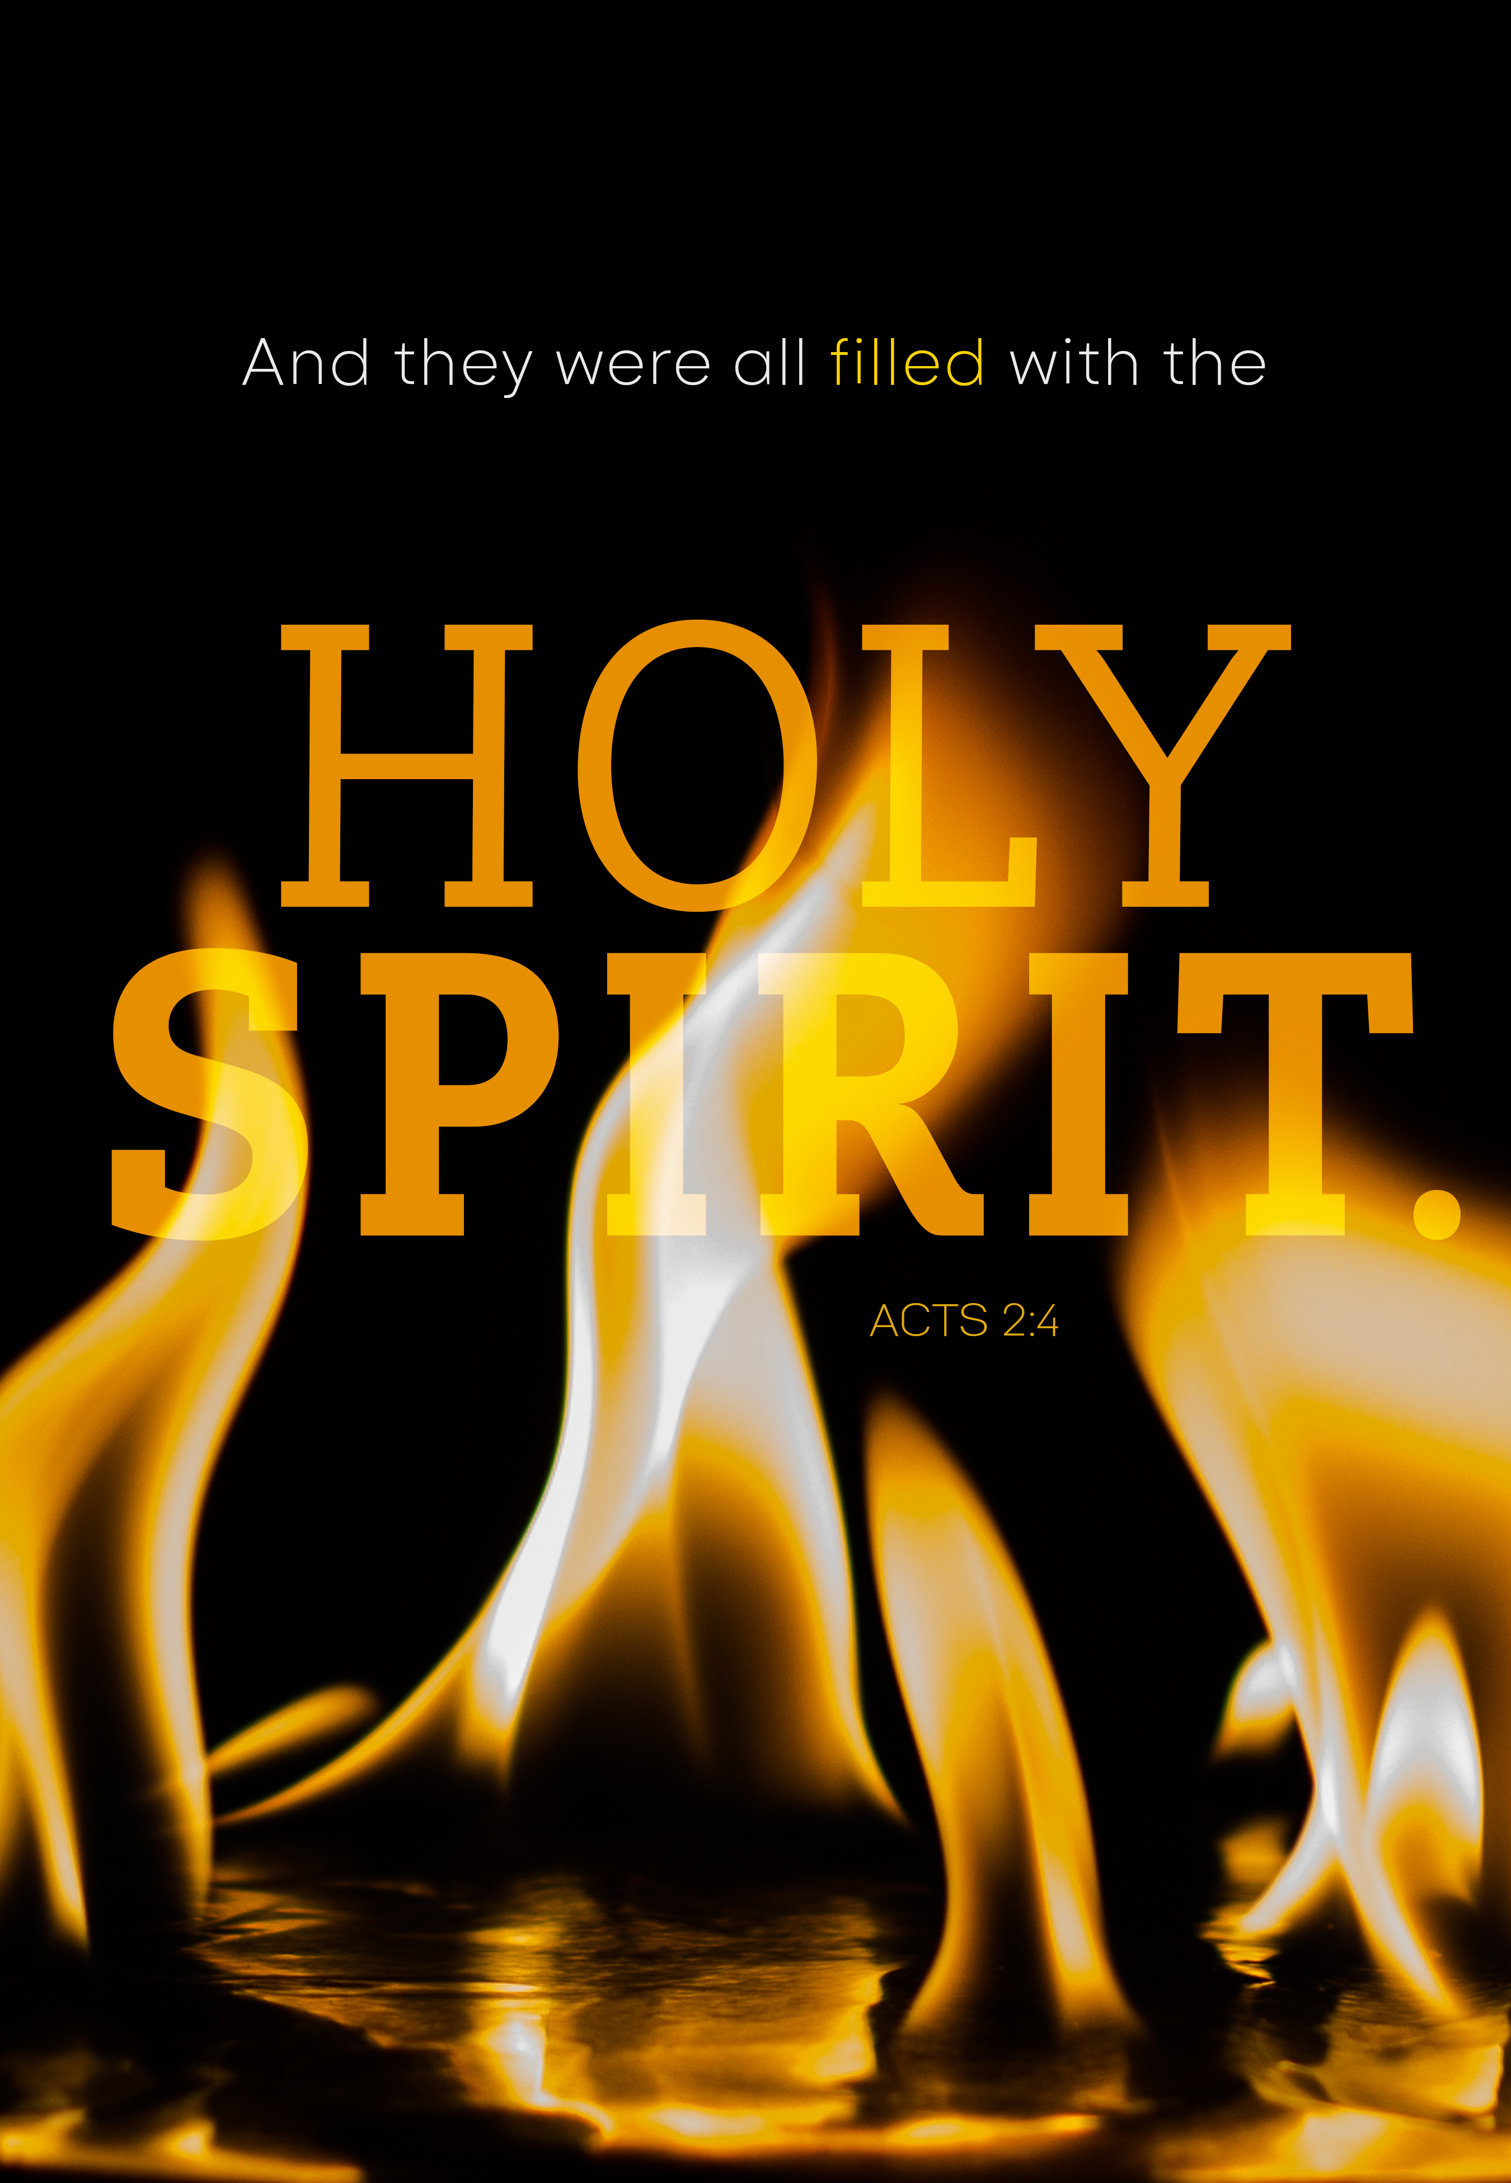
Worship Today

PRELUDES

welcome & announcements

praise god for what he’s done!
outreach in action

CALL TO WORSHIP Isaiah 56:1-8

PRAISE & WORSHIP

SCRIPTURE 1 Corinthians 15:1-11

MORNING PRAYER & LORD’S PRAYER

SPECIAL MUSIC Holy Spirit, Living Breath Of God
Jen Hinton
SCRIPTURE Acts 1:1-5

Message The Community of Believers:
What’s Different?

hymn My Hope Is Built On Nothing Less #343

*BENEDICTION

*Postlude

*Those who are able are invited to stand

Preacher – Pastor Doug Hinton
Worship Leader – Kim Glass
Accompanist – Jen Hinton
Praise Band Leader – Kent Rice
Sound Tech – Rich Bushong & Blaine Garber
Video Tech – Dave Bendit

PREPARE YOUR HEARTS FOR WORSHIP NEXT SUNDAY BY READING AHEAD! Next Sunday, Josh Fulmer will be preaching on Acts 2:5-13, Matthew 28:18-20, Revelation 7:9-12. Please read and prayerfully study this passage this week as we prepare to worship together.

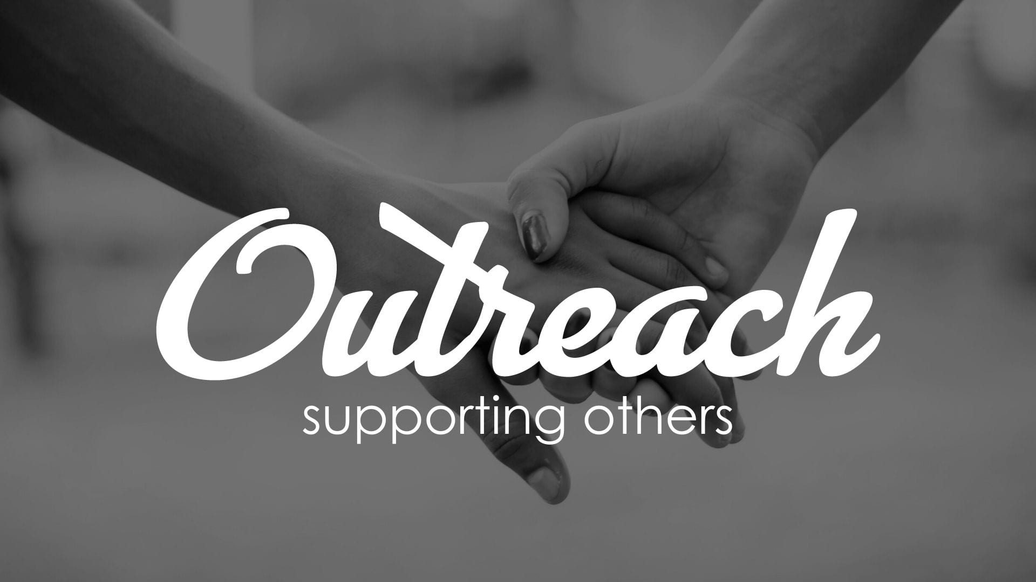
Thank you for sharing through the CHRISTMAS GIVING TREE. You helped distribute funds to our local community and beyond through loving and amazing ways. Below are some examples with the themes of how we helped people impacted by COVID, and other families in need:
- Paid a utility bill for someone hospitalized with COVID
- Helped a person with COVID struggling physically and financially
- Paid for groceries for a family in need
- Helped a neighbor, and are praying they feel the love of Jesus and our church…through our love in blessing them. To God be the Glory!
- Helped to offset the cost of heating fuel to help keep a family toasty warm this winter

More stories will be shared next week on how we loved and served others like Jesus.

.

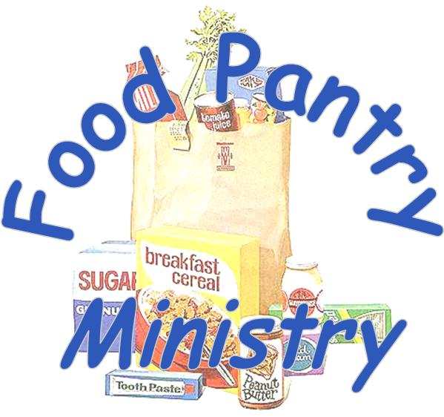
Thank you for your 322 pounds of food items contributed in November.

In November we served:
139 children
269 adults
97 seniors

For a total of 505 people served
We registered 6 new families and re-registered 4 families.
42 volunteers contributed 634 hours to the pantry!

Announcements

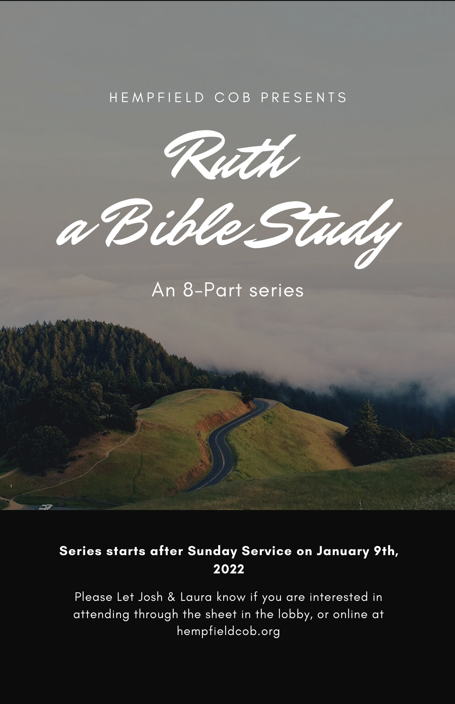

OUTREACH: Paul and Sandy Brubaker, from the Elizabethtown COB will give an update on the Haiti Medical Project on Sunday, Jan 16 during the Outreach in Action segment of our worship service. They will share how the COB is helping Haitian people following the devastating 7.2 magnitude earthquake in August. They’ll also discuss how the church is working in the midst of Haiti’s violence and lawlessness.

Sandy is a board member of Center for Caring, Empowerment Peace Initiative (CCEPI), which was started by Rebecca Dali of Nigeria. CCEPI helps people impacted by terrorism, and provides education for widows and orphans in Nigeria. Rebecca and her husband, Samuel, are COB members, and Samuel was president of the Nigerian COB.  A book was written about Rebecca’s life journey called “We Have Walked in Each Other’s Shoes”. Rebecca has suffered poverty, misogyny, discrimination, violence and because of her suffering she has a heart to help those who have experienced these same tragedies. The book is written for middle school age children but it is enjoyed by adults as well. It’s an excellent book to teach children about other children living in poverty and that education is a primary need of all people. Sandy Brubaker will be in the narthex on Sunday, Jan 16 if you would like to buy the book. It sells for $15 and 100% goes to the ministry of CCEPI. | 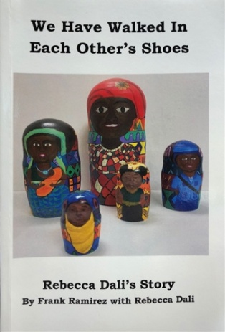
“You are the light of the world…a city on a hill” Matthew 5:14 Rebecca received the 2017 Humanitarian Award from the Mello Foundation at the United Nations office in Geneva in recognition of her courageous efforts to reintegrate women abducted by the Boko Haram back into their local communities in Nigeria.

Sermon Notes

