Contact Us
Hempfield Church of the Brethren
Mailing Address: P.O. Box 246, East Petersburg PA 17520
Physical Location: 1186 Stevens Street, Manheim PA 17545
Website: www.hempfieldcob.org

Our staff members are here to help when you need them. Please feel free to contact them if you have a need.

Doug Hinton – Senior Pastor

Cell: 717-951-5290; E-mail: doug@hempfieldcob.org
Scheduled Day Off: Monday

Josh Fulmer – Youth Minister

Cell: 717-723-7732; E-mail: josh@hempfieldcob.org
Scheduled Day Off: Friday

Geoff Davis – Associate Pastor
Home: 717-569-6284; E-mail: gdavis6320@comcast.net

Laura Meiser – Music Director & Children’s Ministry Co-Coordinator

Cell: 717-689-0465; E-mail: laura@hempfieldcob.org

Emmy Schott – Children’s Ministry Co-Coordinator

Cell: 717-333-8216; E-mail: emmy@hempfieldcob.org

Irene Hershey – Administrator

Phone: 717-898-0181; E-mail: office@hempfieldcob.org
Office Hours: Monday - Friday 9:00 A.M. to 3:00 P.M.
Please submit bulletin information to Irene by Wednesday noon.

HCOB Family Facts
General Offering for January 16, 2022 =
General Fund $ 7330.12
Amount needed weekly to meet budget = $10,512
Building Fund for January 16, 2022 = $ 600.00
Chili Fundraiser for Building Fund: $769.00 (to date)

This Week @ H.C.O.B.
Today: Wednesday:
7:00pm Choir Practice
Monday:
Doug’s Day Off Thursday:
4pm Hempfield Jr High Soccer 4pm Hempfield Jr High Soccer
Tuesday: Friday:
7pm Deacons Josh’s Day Off

Sunday, January 30, 2022
Worship Today

PRELUDES

welcome & announcements

MINISTRY TEAM COMMISSION

CALL TO WORSHIP Psalm 22:22-31

PRAISE & WORSHIP Great Are You Lord
Good, Good Father

SCRIPTURE Matthew 16:13-20

CHILDREN’S TIME

MORNING PRAYER & LORD’S PRAYER

SCRIPTURE Acts 2:42-47

Message On This Rock!

HYMN Doxology #119 vs.A

*BENEDICTION

*Postlude
*Those who are able are invited to stand

Preacher – Pastor Doug Hinton
Worship Leader – Joel Kettering
Accompanist – Jen Hinton
Praise Band Leader – Laura Meiser
Sound Tech –Rich Bushong & Dave Dum
Video Tech – Dave Bendit

PREPARE YOUR HEARTS FOR WORSHIP NEXT SUNDAY BY READING AHEAD! Next Sunday, Doug Hinton will be preaching on
1 Corinthians 8. Please read and prayerfully study this passage this week as we prepare to worship together.

TONIGHT!!! COME JOIN THE FUN!

Sewing Report: In 2021 we made and donated 33 twin, 2 midsize, and 148 baby blankets. The groups receiving them were: Bethany Christian Services, A Woman’s Concern, and Align Pregnancy Center in Columbia. Thank you to all who help with this ministry.
Mary Ellen McEvoy

Welcome Your New Neighbor
The Outreach Team has a ministry to help you welcome your new neighbors. It’s a friendly way to reach out to people who are new to your neighborhood

We assembled a gift bag for you to present to your new neighbor that includes a letter from Pastor Doug, brochures about the church and youth ministry, a $25 gift card to a local business, a copy of the book of John or the New Testament and a “Living” Stone with the reference 1 Peter 2:4-5 which is the basis for our theme – Living Stones, Building Bridges.
Six gift bags were distributed during our first year. All the interactions with new neighbors were friendly and well received. One included a follow-up conversation initiated by the recipient which evolved to a serious discussion of church and God.
As followers of Jesus we want to be the first ones to welcome new people in our neighborhood. We encourage you to participate! Contact Irene Hershey, the Church Administrator, to obtain a welcome bag.

Announcements

Happy January !
In December, 2021, the pantry served 150 families which included 126 children; 236 adults; and 91 seniors for a total of 453 people served.
Clients may visit the pantry once a week….Of the 150 families served, 91 families came more than one week during the month ….. which brought the grand total of people fed in December to 1,345!
The pantry registered 7 new families in December.
Hempfield COB contributed 144 pounds of food in December.
Thank you!
Diane

Food Pantry Needs
Hempfield Food Pantry: Canned carrots, canned mixed vegetables, canned peaches, canned pears, canned sweet potatoes, elbow macaroni
Manheim Central Food Pantry: baked beans, canned fruit, crackers, soup-vegetable beef & clam chowder, spam,
and tissues

Both Pantries are in need of pasta (egg noodles, spaghetti, penna), pasta sauce, mac and cheese, peanut butter, large jelly (no glass containers please), canned corn, canned tomatoes, and cereal.

Meal Ministry Fellowship & Hospitality, Community Care and Deacon Ministry teams are providing soups, applesauce, and breads to our church family. These items are primarily for our church shut-ins who may be experiencing illness, or food shortage.

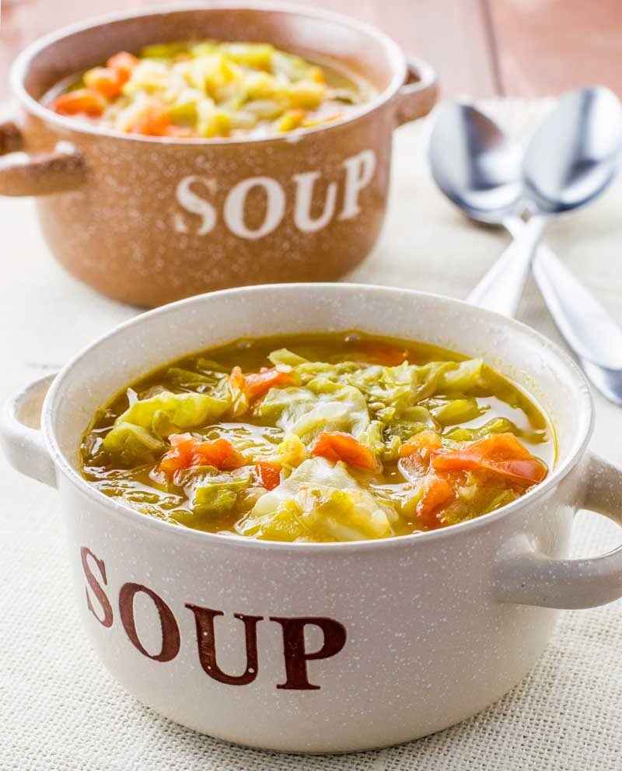
Future Soup Building Fundraisers:
Jan 29. 8-10:30 & Jan.30 (TODAY) after the morning service - Vegetable Beef soup
March 12 8-10:30 & 13 after the morning service - Chicken Noodle corn soup Suggested donation is $10 per quart.

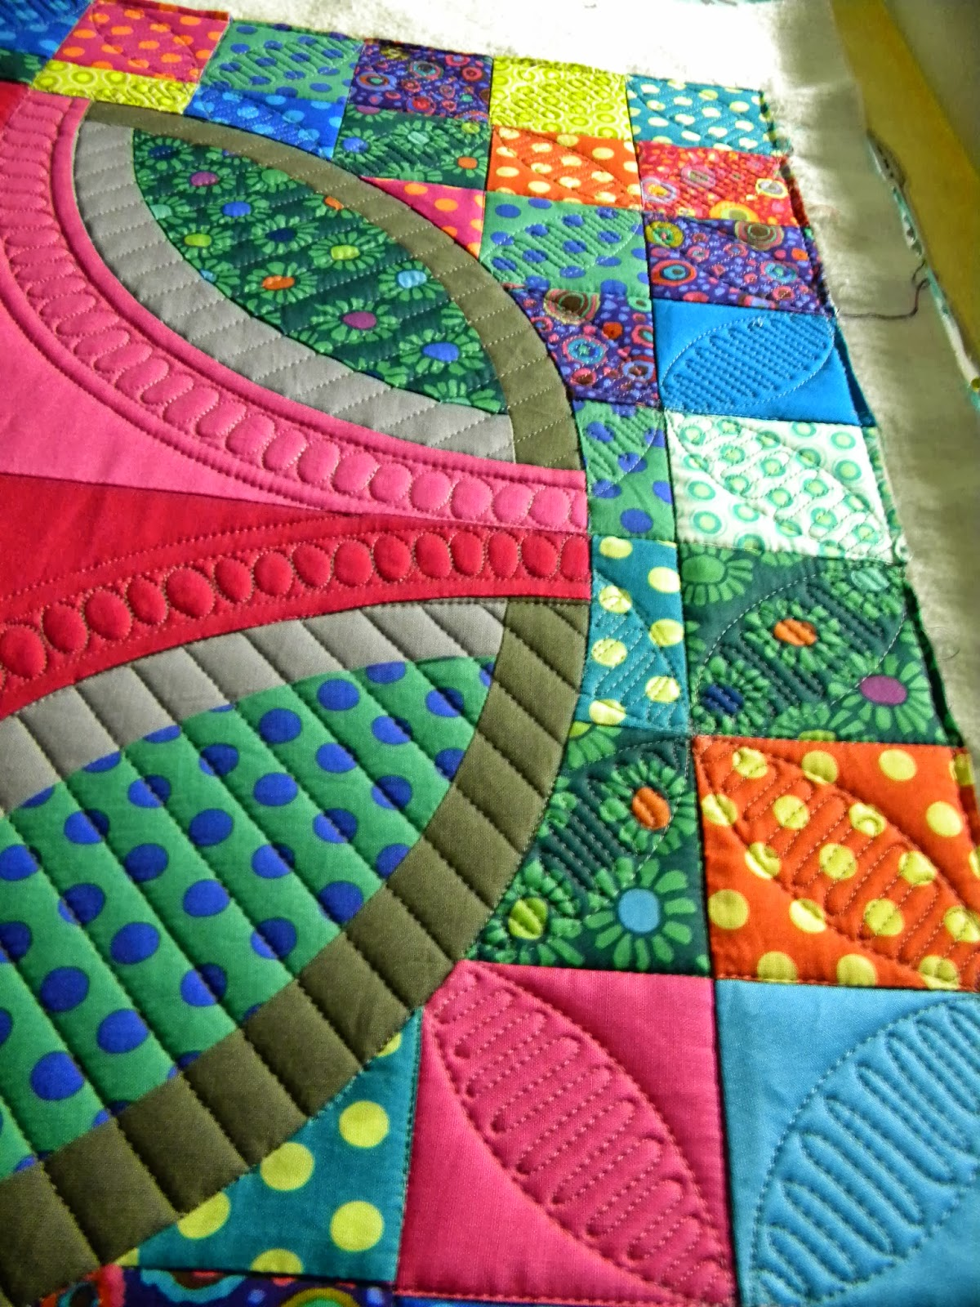
HCOB’s Quilting Group would like to invite anyone interested in learning how to quilt to visit with us at church on Wednesday mornings, any time from 8:00 to 11:00. You can observe our expert quilters as they hand-quilt the Disaster Relief quilts, and get one-on-one instruction during that time. If Wednesday mornings don’t work with your schedule, please contact Deb Bendit (717-808-8453 or quilterdeb60@gmail.com) to arrange a time that works for you. We look forward to helping you learn a new skill!

*Please note that on the SECOND Wednesdays of the month the quilters and sewers come together to create and knot beautiful comforters, and you are most welcome to join us then also! If you can tie your shoes, you can knot a comforter! *

Sermon Notes

