Contact Us
Hempfield Church of the Brethren
Mailing Address: P.O. Box 246, East Petersburg PA 17520
Physical Location: 1186 Stevens Street, Manheim PA 17545
Website: www.hempfieldcob.org

Our staff members are here to help when you need them. Please feel free to contact them if you have a need.

Doug Hinton – Senior Pastor

Cell: 717-951-5290; E-mail: doug@hempfieldcob.org
Scheduled Day Off: Monday

Josh Fulmer – Youth Minister

Cell: 717-723-7732; E-mail: josh@hempfieldcob.org
Scheduled Day Off: Friday

Geoff Davis – Associate Pastor
Home: 717-569-6284; E-mail: gdavis6320@comcast.net

Laura Meiser – Music Director & Children’s Ministry Co-Coordinator

Cell: 717-689-0465; E-mail: laura@hempfieldcob.org

Emmy Schott – Children’s Ministry Co-Coordinator

Cell: 717-333-8216; E-mail: emmy@hempfieldcob.org

Irene Hershey – Administrator

Phone: 717-898-0181; E-mail: office@hempfieldcob.org
Office Hours: Monday - Friday 9:00 A.M. to 3:00 P.M.
Please submit bulletin information to Irene by Wednesday noon.
HCOB Family Facts
General Offering for April 24, 2022 =
General Fund $ 6,774.15
Amount needed weekly to meet budget = $10,512
Building Fund for April 17, 2022 = $ 100.00

This Week @ H.C.O.B.

Today: Wednesday:
7:00pm Choir Practice
Monday: Thursday:
Doug’s Day Off 6pm Praise Band

Tuesday: Friday:
7:00pm Deacons Josh’s Day off
Sunday, May 1 , 2022

Worship Today

PRELUDES

welcome & announcements

CALL TO WORSHIP Psalm 4

VOICES IN PRAISE Goodness of God
Raise a Hallelujah

SCRIPTURE Ephesians 4:1-6
One: As a prisoner for the Lord, then, I urger you to live a life worthy of the calling you have received. Be completely humble and gentle; be patient, bearing with one another in love. Make every effort to keep the unity of the Spirit through the bond of peace. There is
All: One body and one Spirit—
One: just as you were called to…
All: One hope…
One: When you were called—
All: One Lord, one faith, one baptism; one God and Father of all,
One: who is over all and through all and in all.

MORNING PRAYER & LORD’S PRAYER

SPECIAL MUSIC Worthy is the Lamb
Sanctuary Choir
SCRIPTURE Ephesians 4:25-32

Message There is another way
With Pastor Gerald Simmons and Pastor Robert Corsey

HYMN Great Is Thy Faithfulness #327

*BENEDICTION Prayer by Melani Raffensperger
“God created me.
He loves me just like I am.
I am kind and loving and considerate of other people.
I am understanding.
Jesus fills my heart with joy and hope and gladness.
I am not alone.
God is with me and people care for me.” Amen
*Postlude
*Those who are able are invited to stand

Preacher – Pastor Doug Hinton
Worship Leader – Diane Garber
Accompanist – Jen Hinton
Praise Band Leader – Jen Hinton
Sound Tech –Rich Bushong & Blaine Garber
Video Tech – Doug Howard

PREPARE YOUR HEARTS FOR WORSHIP NEXT SUNDAY BY READING AHEAD! Next Sunday, Doug Hinton will be preaching on
Ephesians 4:1-6, 25-32. Please read and prayerfully study this passage this week as we prepare to worship together.

We offer a tremendous THANK YOU to Pastors Gerald Simmons and Robert Corsey for joining us in worship this morning. We are blessed to have you with us today!

The Worship Team would like to bless an organization with our old Songs for Praise and Worship books that are no longer used. If any of you would like a copy of the book, you may pick them up from the cardboard boxes that will be in the Fellowship Hall through the end of May.

Richard and Carolyn Gingrich again have a direct mailbox. Their current address is: 2344 Lancaster Road, Manheim, PA 17545

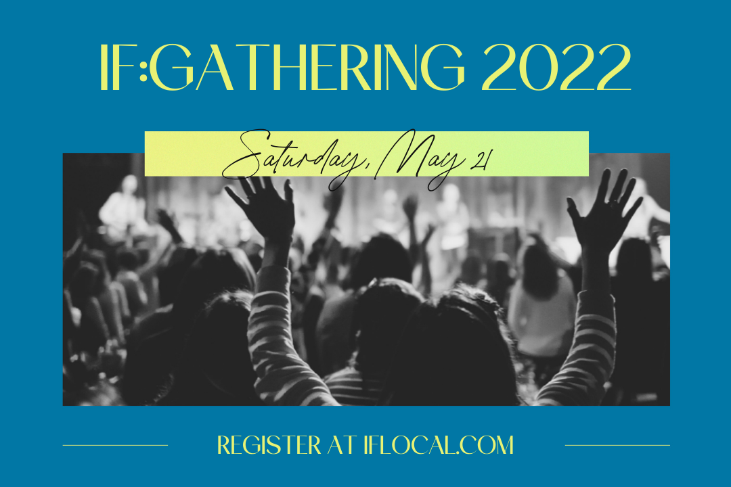

Ladies, please plan to join us for IF:Gathering 2022 to be hosted at HCOB on Saturday, May 21 from 9:30 AM to 4:00 PM. Join us for praise and worship, conversation and most importantly solid Biblical teaching. In this season in which darkness feels like it's pressing in, we can push back with courage in Jesus’ name. We'll hear from speakers such as Jennie Allen, Jackie Hill Perry, Ann Voskamp, and more. The cost for this event is only $10 and lunch and snacks will be provided. For more information,feel free to contact Laura Meiser (laura@hempfieldcob.org or 717.689.0465) You can register here: https://watch.if2022.com/register/join-group?groupid=21932

Announcements

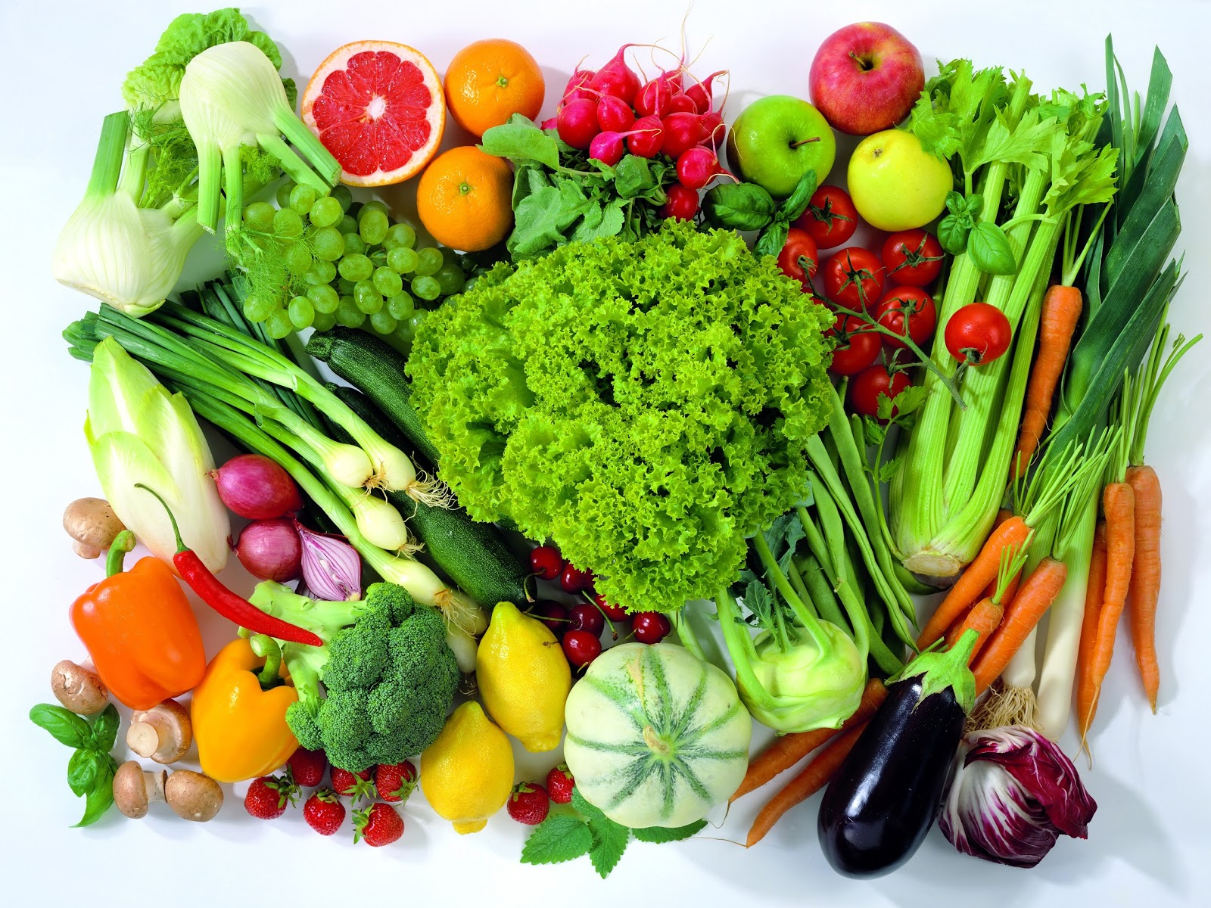
Just a friendly reminder. . . . . . With the approach of summer and the many bountiful gardens we often have in our congregation, we still have cookbooks for sale at the church to give you some great ideas on how to use those tasty fruits and vegetables.

The Outreach Team is planning to have an Ice Cream Social at Constitution Square in East Pete again and YOU are invited to help serve ice cream to the community. Mark your calendars for Friday, May 13 from 6 to 7:30 pm. We plan to serve free ice cream at three locations. Come and bless our neighbors and their kids. Contact Jen Houck at 717.951.7694 by May 6 if you want to participate or have questions.

We will be holding a baptismal service on Sunday, May 29th during the morning service. If you have not taken this step of faith and would like to, please contact Pastor Doug.

ATTENTION!! Spring has sprung and that means it is time to play, play, play….SOFTBALL that is. Our church is, again, supporting a softball team playing in the Manheim Church League. We are very interested in you! If you would like to participate in some fellowship on the softball field, please speak to Ed Haldeman, or Doug Howard. COME ON OUT!!

Hempfield COB Creation Music Festival Trip.
Hempfield COB Youth have 20 tickets to attend the festival. It is a fun weekend of music, camping, and fellowship. If you are interested in joining us this year, please contact Josh Fulmer or Ed Haldeman.

Tom, Katlyn & Kim Glass wish to thank everyone for their prayers, cards, meals and well wishes through Kim’s surgery and time of healing. It is very much appreciated.

VBS 2022!! Join us for the Jerusalem Marketplace

June 6-9,2022
Register at: vbspro.events/p/9cde03

WE NEED YOUR HELP!!! There are plenty of spaces to be involved in this wonderful ministry to the children of our area. Please take a moment to visit the sign-up sheet in the Narthex and plan to do your part! If you have specific questions, please see Emmy Schott or Laura Meiser – they will be happy to guide you to where your talents can best be used.

FOOD PANTRY UPDATE -

96 pounds of food items contributed to the pantry in March.

In March we served 136 families…. which included 144 children, 268 adults, 107 seniors for a total 519 people. Many families visit the pantry every week which gives our total people fed in March at 1,570.
Current requested items are: Cereal, Mac/cheese, Soups, Canned mixed vegetables, Canned carrots, Canned corn, Canned fruit cocktail, Canned salmon, Canned potatoes, Pancake mix, Ramon noodles.

